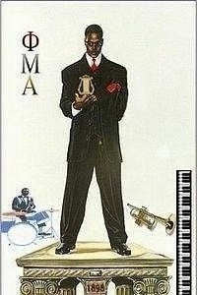 Sinfonica
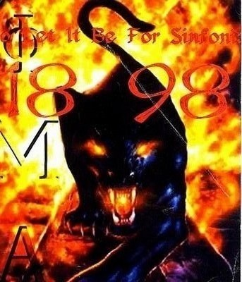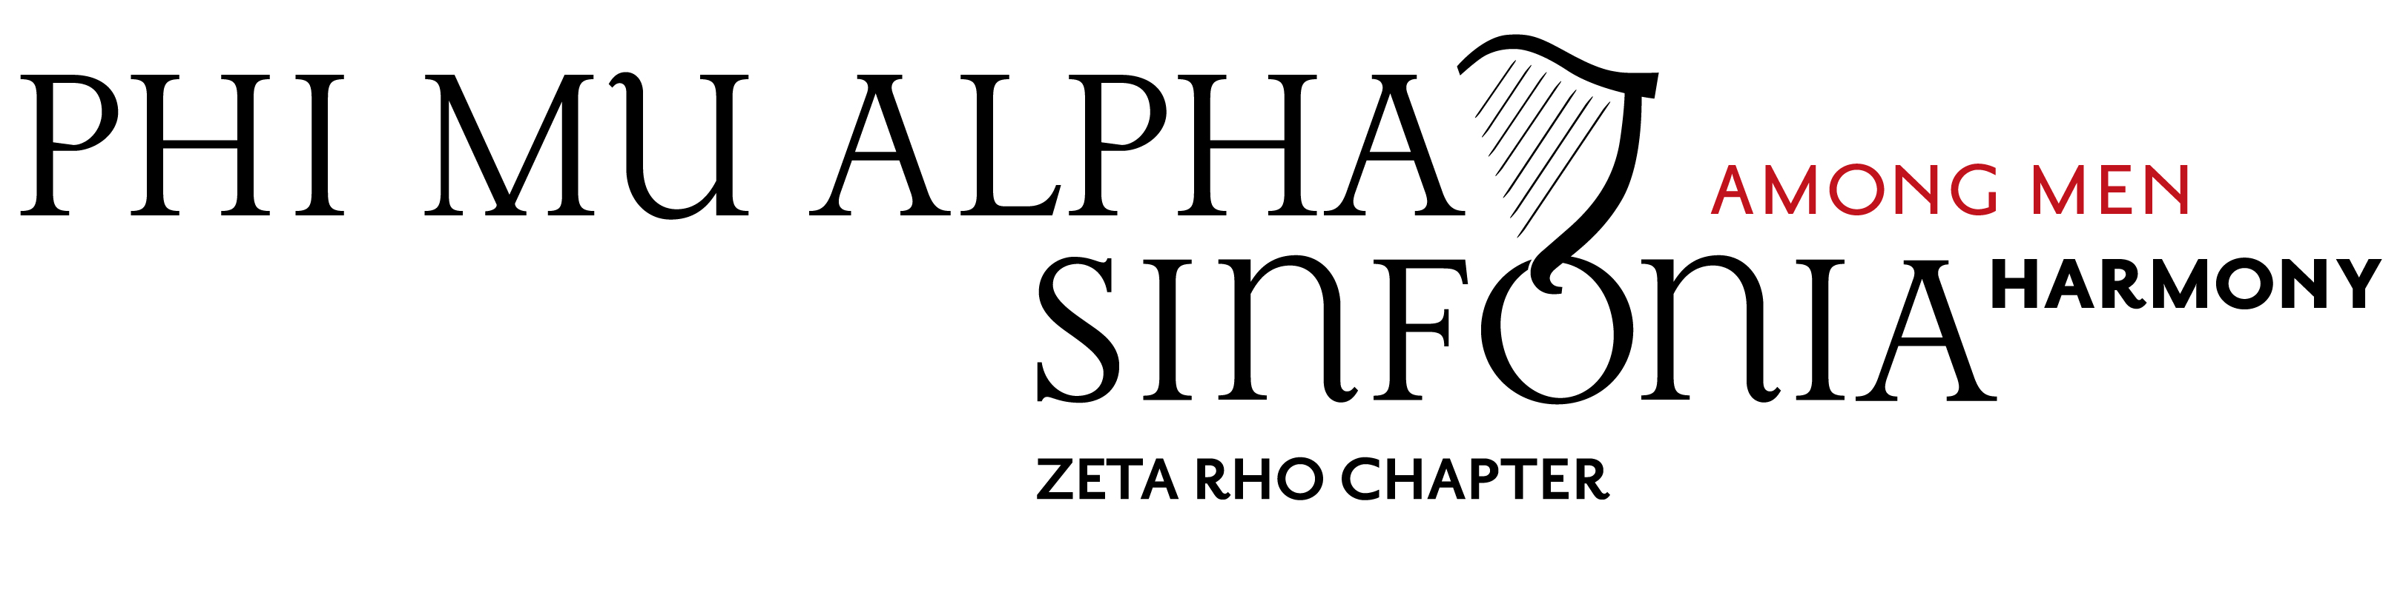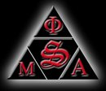
Volume 4, No. 3, May 23, 2009

Graduating Sinfonians

Two more Sinfonians bear the title of “Fisk Alumnus” as of May 4, 2009.

Troika K-Rel Hanna (New A) was graduated with the BA in Music. He is the first to complete the Music Business Minor in collaboration with the Mike Curb College of Entertainment and Music Business. While at Fisk, Troika won awards in the James A. Hefner HBCU Piano Competition and the Margaret A. Guthman Keyboard Competition. He plans to pursue the Masters in Music Performance at Belmont University.

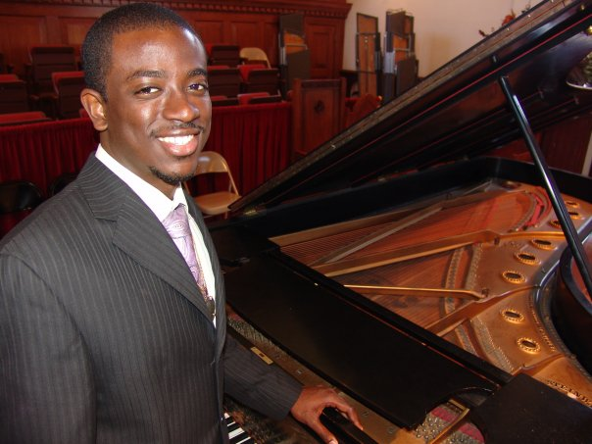
Courtesy Fisk University Media Services.

Stewart Lancaster Voit II (New Zeta) was graduated with the B.A. in Chemistry. He plans to pursue the Master of Science in Chemistry at Fisk University. Stewart will remain active in Sinfonia, and has been elected to the position of Vice-President/Fraternity Education Officer for 2009–2010.

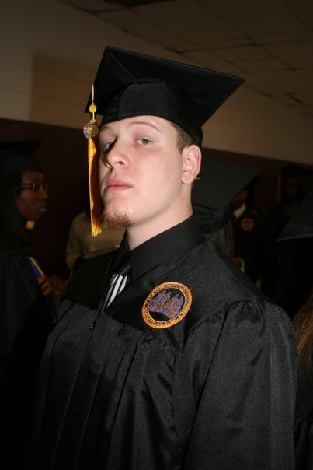

Photo courtesy of
U-Dub Photography

The Second Phi Mu Alpha Ball

The Fisk University Jazz Ensemble, directed by Dr. Gary Powell Nash (ΔΙ ‘87) headlined the Phi Mu Alpha Ball on February 21. Other performers included De’Andre Jones, Kaylina Madison, and Sinfonians from the Zeta Rho Chapter. The Phi Mu Alpha Ball has become the main fundraiser for the Chapter, with ticket sales supplementing donated items and services.

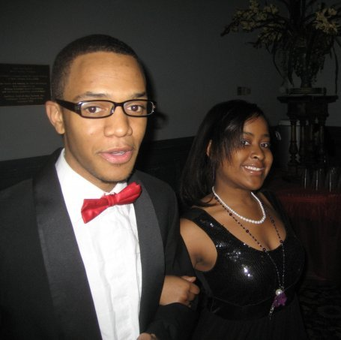



Photos courtesy of U-Dub Photography

* * * * * * *
Devin Mikell, Editor
zetarhochapter@hotmail.com
Zeta Rho Chapter
Phi Mu Alpha
Fisk University Music Department
1000 Seventeenth Avenue, North
Nashville, Tennessee 37208

Sinfonian Elected to MTNA Presidency

Zeta Rho Congratulates Dr. Benjamin D. Caton III (ΛΣ ‘67) of East Tennesse State University upon his selection as the President-Elect of the Music Teachers National Association. Dr. Caton will serve as President during the 2011–2013 biennium. MTNA was founded in 1876 by Theodore A. Presser (A ‘17) and 62 colleagues in Delaware, Ohio, and has about 24,000 members.

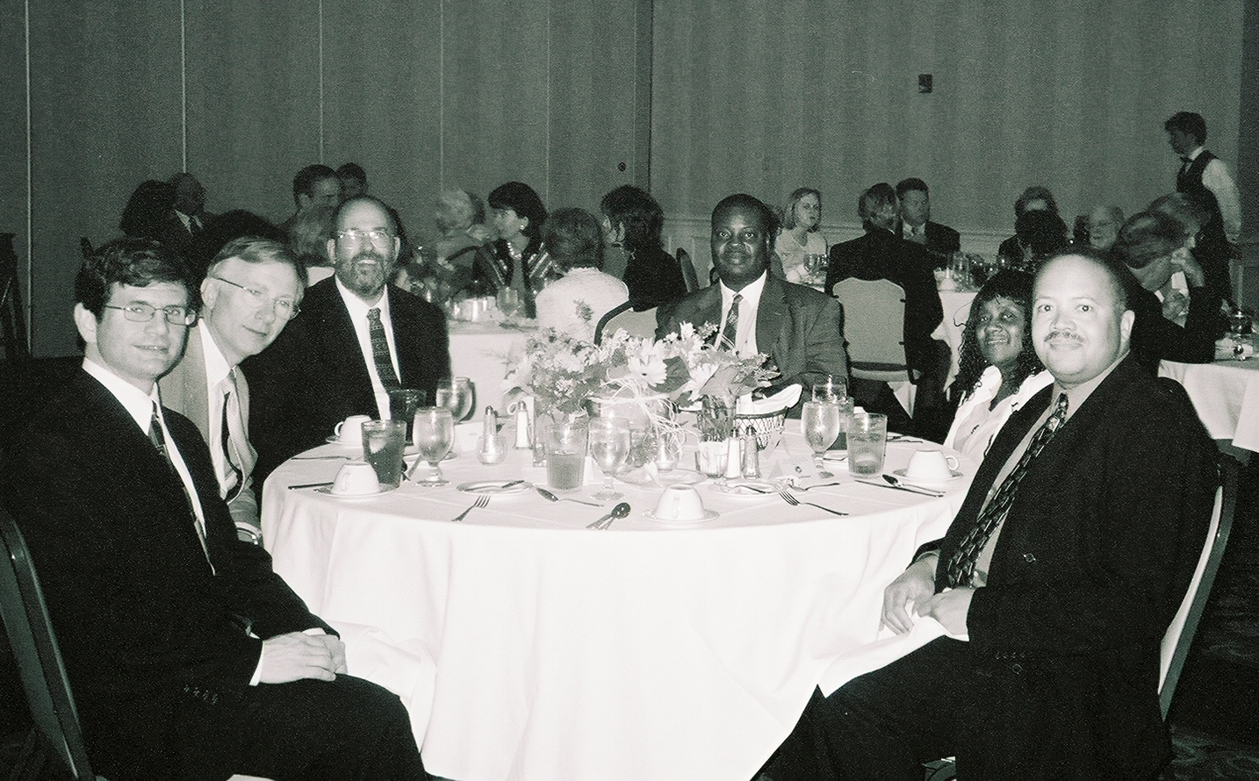

Ben Caton (second from right) at the 2006 Tennessee Music Teachers Association Conference Banquet in Memphis. L to R:
Philip Autry (ZP advisor), Ben Caton, Terry McRoberts (PG 15), Gary Powell Nash (ZP advisor), Millie Nash , Anthony Williams. Photo courtesy of TMTA.

National Convention
The triennial National Convention will be held in Orlando, Florida, July 15–19, 2009. Register by visiting www.sinfonia.org

Chapter Day
The Zeta Rho Chapter was founded May 23, 1953. The 56th Chapter Day will be observed at 12:30 p.m. on Tuesday, May 26, 2009. Due to simultaneous renovations of the Harris Music Building and Jubilee Hall, the ceremony will be held at the home of Dr. Philip Autry; 603 Kennington South, Nashville, Tennessee 37214. For more details: 615.889.4624.
Zeta Rho Sponsors Piersen Lecture

ZP led the effort to raise funding for the 2009 Piersen Lecture, presented by the Fisk University History Department. The lecture series is an annual event named in honor of the late William Piersen, that exists to provide primary research information on Fisk University. This year’s lecture was presented by Dr. Philip Autry (ΜΓ ’99), Chair of the Fisk Music Department, who presented “The Instrumental Music of John W. Work III.” Dr. Autry was joined by Fisk/TSU violin instructor Stefan Petrescu, Fisk Piano Performance Majors Kaylina Madison and De’Andre Jones, and guests Ai Ishihara (TSU graduate student) and Zhengyang Cong (MLK Academic Magnet High School). Music presented included the piano works Appalachia, Scuppernong, and Sassafras, as well as Movement I, a manuscript for two pianos based on the string symphony Yenvalou, and Nocturne for violin and piano.
L: Zhengyang Cong in a lesson on Sassafras at Dr. Autry’s home studio.

B: Kaylina Madison and Ai Ishihara rehearse the Movement for Two Pianos

Dr. Philip Autry performs Appalachia during the 2009 Piersen Lecture. Photo courtesy of
U-Dub Photography



Funding and services were provided by Steinway Piano Gallery of Nashville, You in Music and ZP, who submitted grants to the John Work III Memorial Foundation and the Sinfonian Foundation. The request to the Memorial Foundation was successful.

As Professor Work was a collaborator with university personnel Arna Bontemps (A Class) and L.M. Collins (English), government entities (Library of Congress) and other universities (Fort Valley State University), this program brings together persons from both the Fisk University music and history departments with personnel from Fisk, Tennessee State University, and Martin Luther King, Jr. Academic Magnet High School.

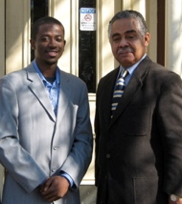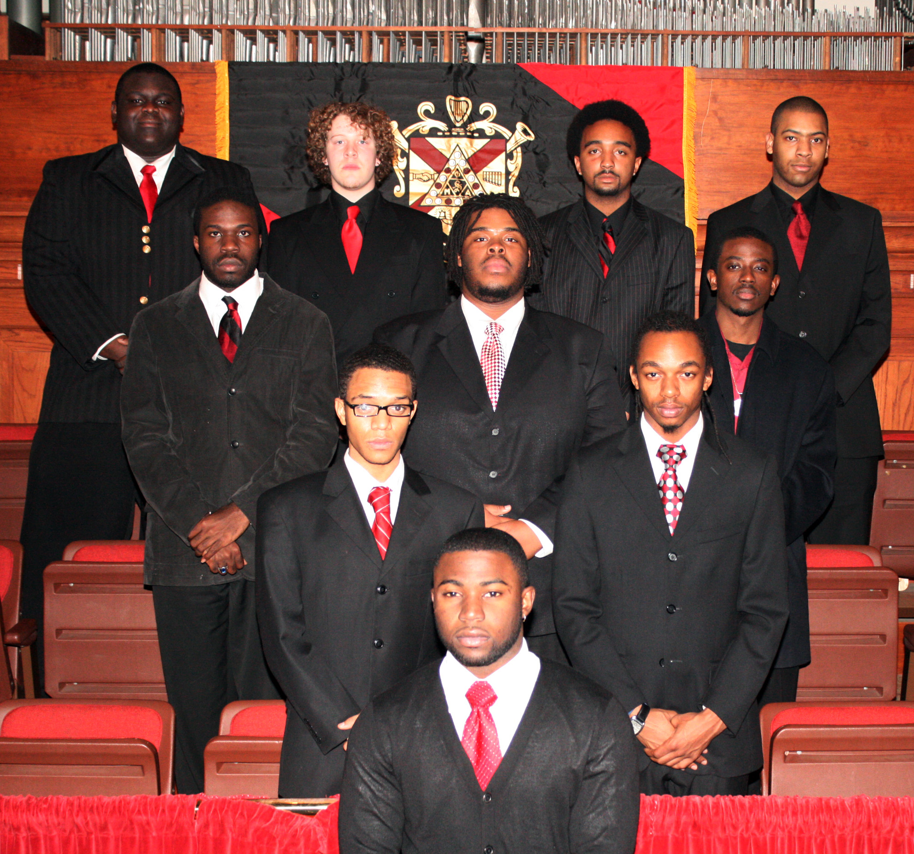

L: Troika Hanna (New A Class), CEO of You in Music, with Dr. Reavis Mitchell, Chair of the Fisk University History Department. Photo courtesy of You in Music. R: The Zeta Rho Chapter of Phi Mu Alpha Sinfonia. File photo.

This project’s outreach begins with collaboration between Work’s two academic departments: History and Music. He held the B.A. in History from Fisk and was chair of the Fisk Music Department.

The guest performers, representing Nashville’s diverse community of music students and faculty, were introduced to Professor Work’s music for the first time in the development of the project.



Professor Work is considered to be the founder of the ZP Chapter, for it was his correspondence with the Fraternity that led to its establishment at Fisk on May 23, 1953. Following his presentation, Dr. Autry was awarded the Ridley-Jones Prize, a repose designed by the late Gregory Ridley and produced by Ted Jones.

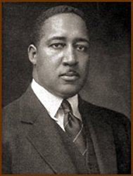

John W. Work III (Alpha Class)
Index Vol. 4

No. 1, October 6, 2008
From the Alumni Secretary
Steven Hunter (New Γ) Completes M.A.
Founder’s Day
AY 2009 Begins with Mills Music Mission and Anti-Hazing Workshop
Fundraisers and Service
Alumni Sinfonians attend First HBCU Conductors Summit and National Honors Choir Performance

No. 2, January 25, 2009
New Zeta Class
Sinfonians at the White House
Sinfonian P.J. Moton in Ragtime
Sinfonian William Chapman Nyaho
Sinfonians Discuss Fisk’s Musical Contributions
Sinfonians at School
Life-Loyal Sinfonian

No. 3, May 23, 2009
Graduating Sinfonians
The Second Phi Mu Alpha Ball
Sinfonian Elected to MTNA Presidency
National Convention
Chapter Day
Zeta Rho Sponsors Piersen Lecture

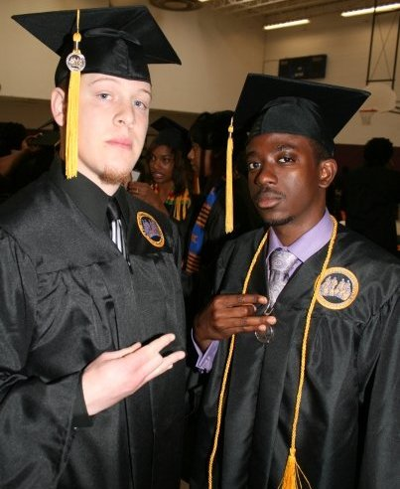
L: Stewart and Troika before Commencement.

B: Attendees of the Ball

Photos courtesy of U-Dub Photography.
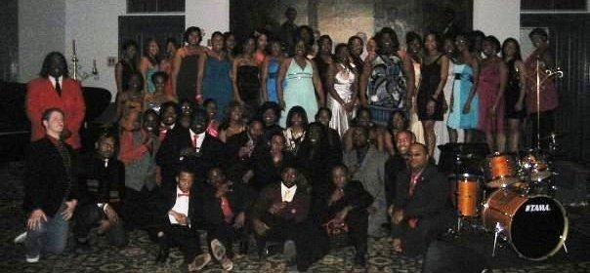

Officers 2008–2009
President Willis Ware
Vice President Rashaan Forbes
Alumni Relations Devin Mikell
Warden Preston Wilson Secretary Troika Hanna
Treasurer Jermaine Johnson
Fraternity Education (FEO) Jordan Holland
Historian P. J. Moton
Province Council Representative Adrian Smith

Officers 2009–2010
President Willis Ware
Vice President/FEO Stewart Voit
Secretary/Treasurer Jordan Holland
Warden Matthew Owens
Alumni Relations TBA
Historian TBA
Province Council Representative TBA

