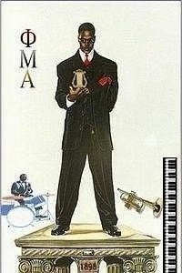 Sinfonica
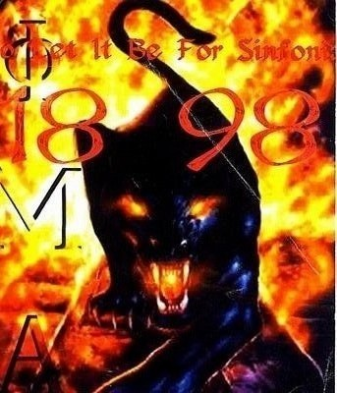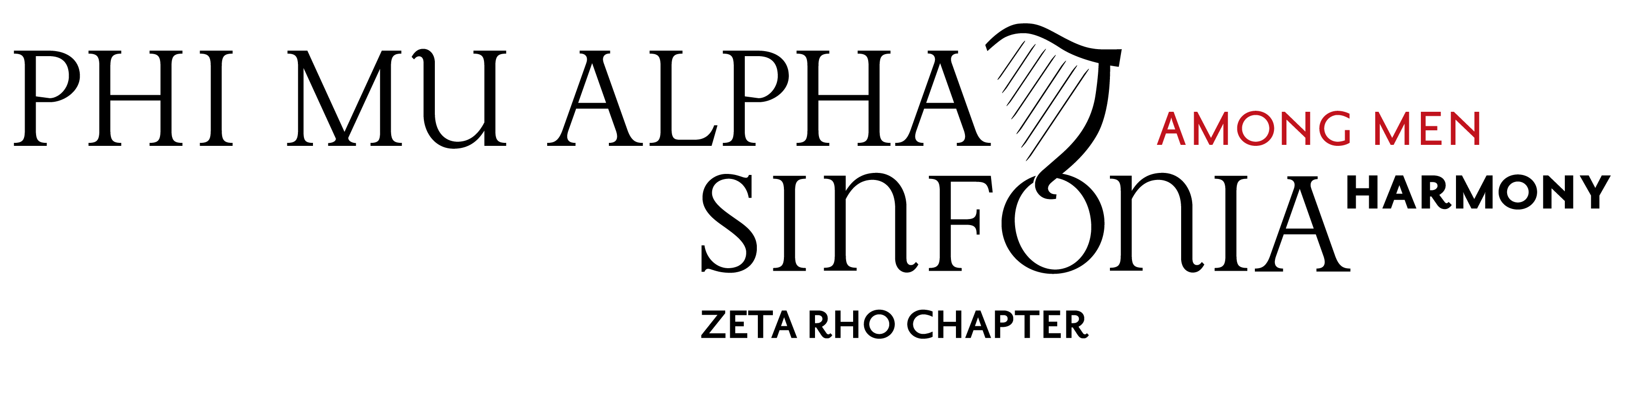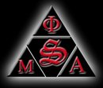
Volume 4, No. 1, October 6, 2008

From the Alumni Secretary

Greetings and salutations, fellow Sinfonians.

I am Devin Mikell of the New Alpha class of the Zeta Rho Chapter here at Fisk. A Super-Senior in my last semester of matriculation at Fisk, I am serving as the new Alumni Relations officer for the 2008–2009 school year. I look forward to having some kind of relation and connection to all my fellow Zeta Rho alumni and even other Sinfonia alumni in the coming months. I previously served as FEO, Vice President, and Province Council Representative in the chapter, and as secretary in our reactivation process. Now as the Alumni Relations officer, I hope to reach out to you all and link the past Zeta Rho with the modern Zeta Rho and hopefully create new bonds between us all. I also hope that as alumni of such a prestigious organization as Sinfonia, you can help us with your ideas and wisdom, and even shine light on the previous days at Fisk. We welcome your visits with the brothers as lightbearers of the torch that you have passed to us. We welcome news articles about alumni brothers from 1953 to the present. We appreciate you all alumni and I personally look forward to working with each and every one of you.

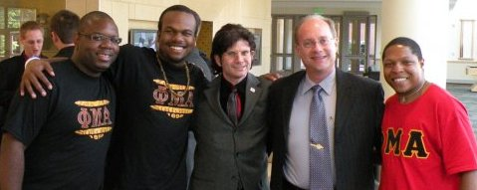

December 2008 graduates Devin Mikel (New Α) and Joshua Jeter (New B), Faculty Advisor Philip Autry, National President Richard Crosby, and Alumnus Darrel Jones (New Α) after the ceremony at the 2008 Leadership Institute in Nashville. Photo courtesy of Larry Coonfare (ΘΣ).

Steven Hunter (New Γ) Completes M.A.

In May 2008, Steven Hunter ’05, completed the Master of Arts degree with a concentration in Biblical Studies from Iliff School of Theology in Denver, Colorado. Steven was one of the six officers in the Fisk Sinfonics whose tireless efforts led through Phase I of the Zeta Rho reactivation process. He was invited back in December 2006 to become a member of the New Γ Class. Congratulations to Steven on his newest accomplishment.

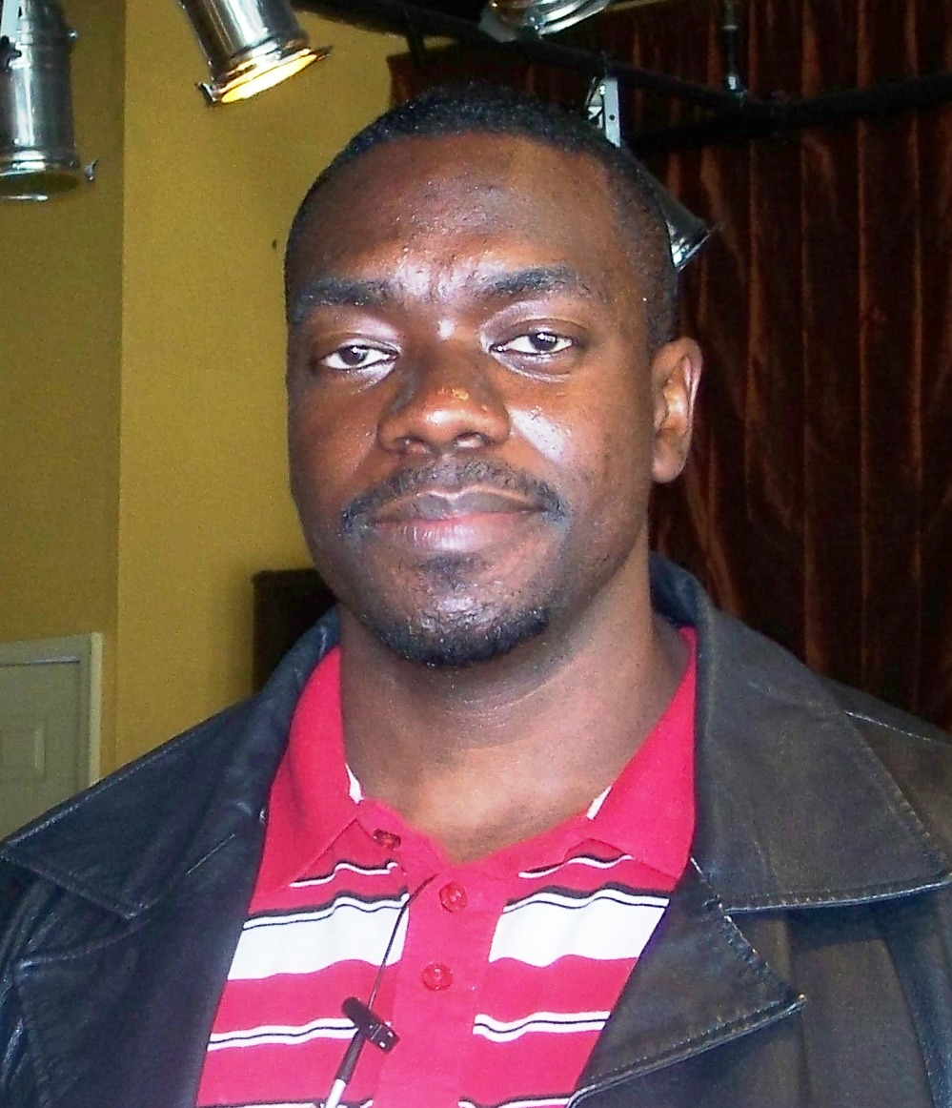
Steven Hunter, M.A.

Founder’s Day
Theta Tau (Austin Peay State University) will host a Province-Wide Founders Day Ceremony on Sunday, October 5, 2008 at 4 p.m. For more information, please contact Assistant CPR Mario Kee at mkee14@apmail.apsu.edu.
* * * * * * *
Devin Mikell, Editor
zetarhochapter@hotmail.com
Zeta Rho Chapter
Phi Mu Alpha
Fisk University Music Department
1000 Seventeenth Avenue, North
Nashville, Tennessee 37208

AY 2009 Begins with Mills Music Mission and Anti-Hazing Workshop

The first activity of 2008–2009 year was a Mills Music Mission at Lakeshore Heartland on Saturday, August 30. The residents were thrilled to hear alumni, students, and faculty perform music in a variety of styles and sung by soloists from Ohio, New York, North Carolina, Illinois and Texas.

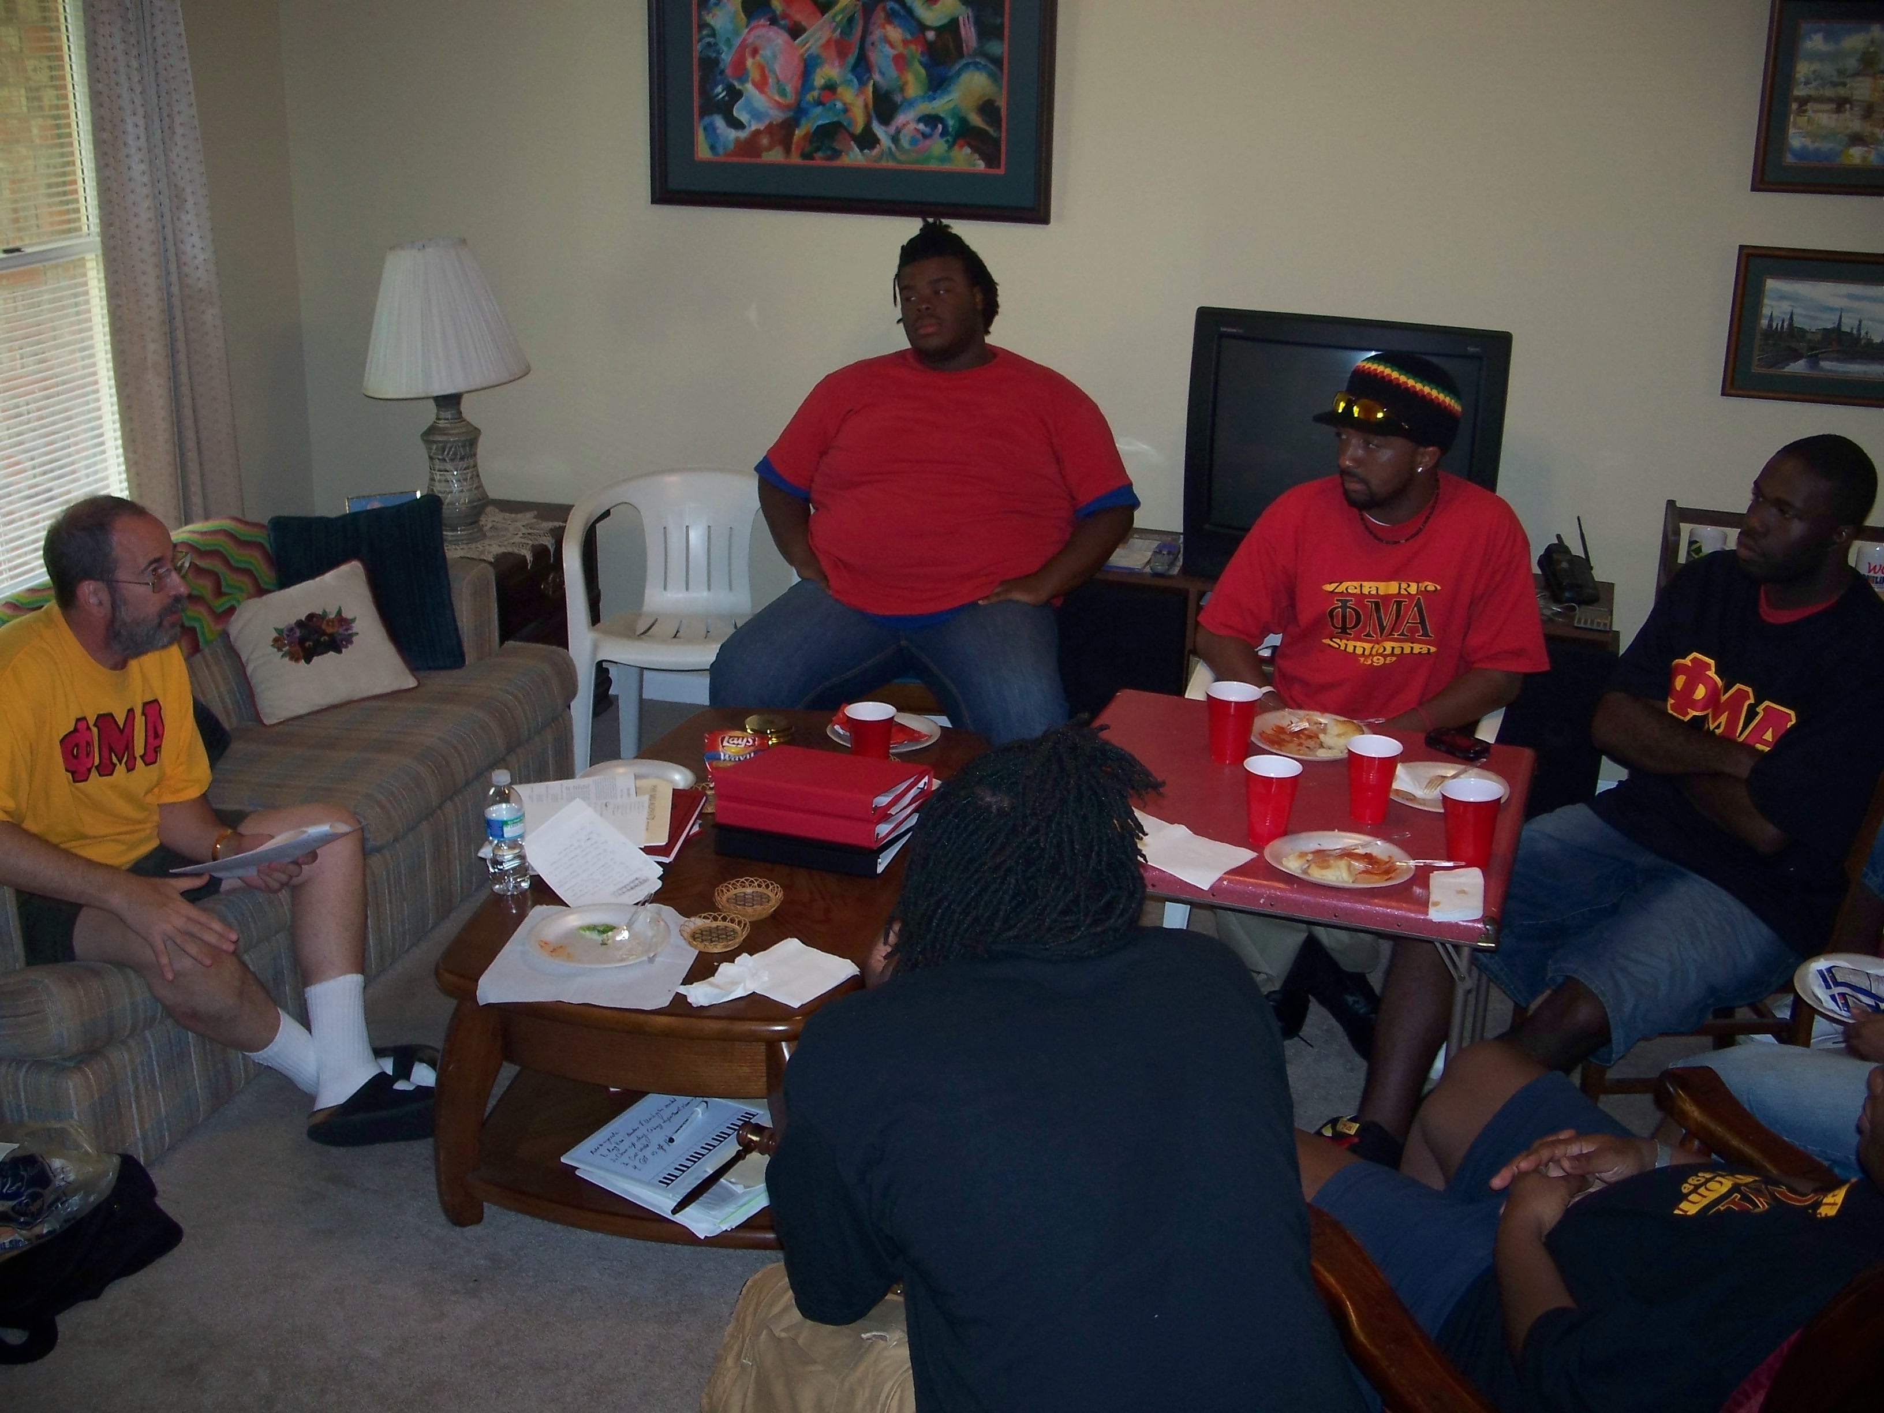

After the Mission, the brothers visited with Province Governor, Dr. Terry McRoberts (PG 15) for sessions on Fraternal Obligation and an Anti-Hazing Workshop.

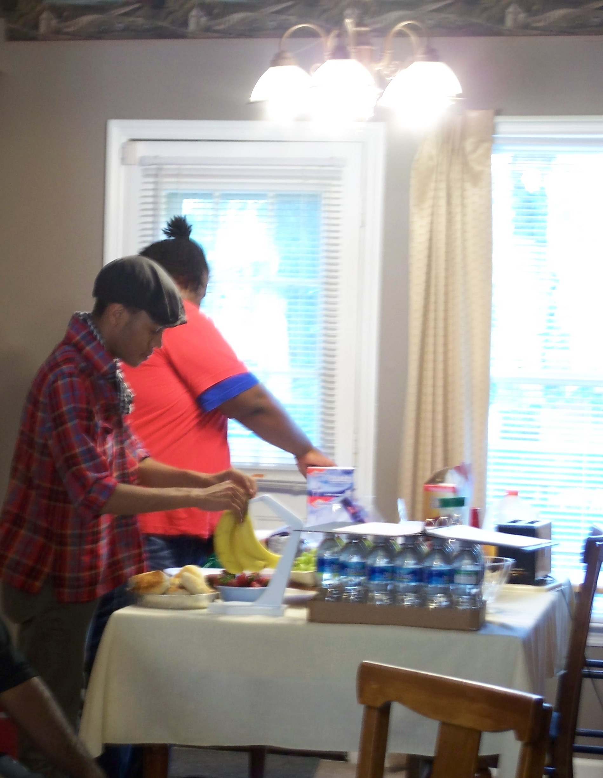
Fundraisers and Service

The Zeta Rho Car Wash returned on September 13 after a two-year absence. We met at the Krystal on Charlotte to catch Saturday shoppers on their way to Wal-Mart and Lowes.

Sinfonia’s first University Service activity of the year was to clean and straighten Harris 111, the Fisk Jubilee Singers® Rehearsal Hall, getting it ready for classes and rehearsals to begin.

Alumni Sinfonians attend first HBCU Conductors Summit and National Honors Choir Performance

On September 4, 2008, students from 105 Historically Black Colleges and Universities across the U.S. arrived in Washington DC to rehearse for the first annual HBCU National Honor Choir performance. Students in rehearsals wore shirts representing Sinfonia, ΕΑΙ, ΚΚΥ, and ΤΒΕ. Conductors who are Sinfonians included David Morrow (ΞΗ) from Morehouse College and Curtis Powell (ΙΒ) from Delaware State University. Conductors and music administrators met on Saturday, September 6, for workshops and sessions. The keynote speaker was respected Choir director Dr. James Arthur Williams (ΓΗ). Sinfonian attendees included Clarence E. Knight, Jr. (ΖΙ) from Bowie State and Fisk alumnus Horace R. Carney (ΟΔ) from Alabama A&M. The Fisk University Music Department was awarded the Presidential Legacy Award which includes a $2500 donation to the Fisk University Music Department. The premiere performance of the National Honor Choir was Sunday, September 7, in the John F. Kennedy Center for the Performing Arts. Representing Fisk in the Choir was soprano Kelsey Porter, a Junior Vocal Performance Major from Memphis, Tennessee.

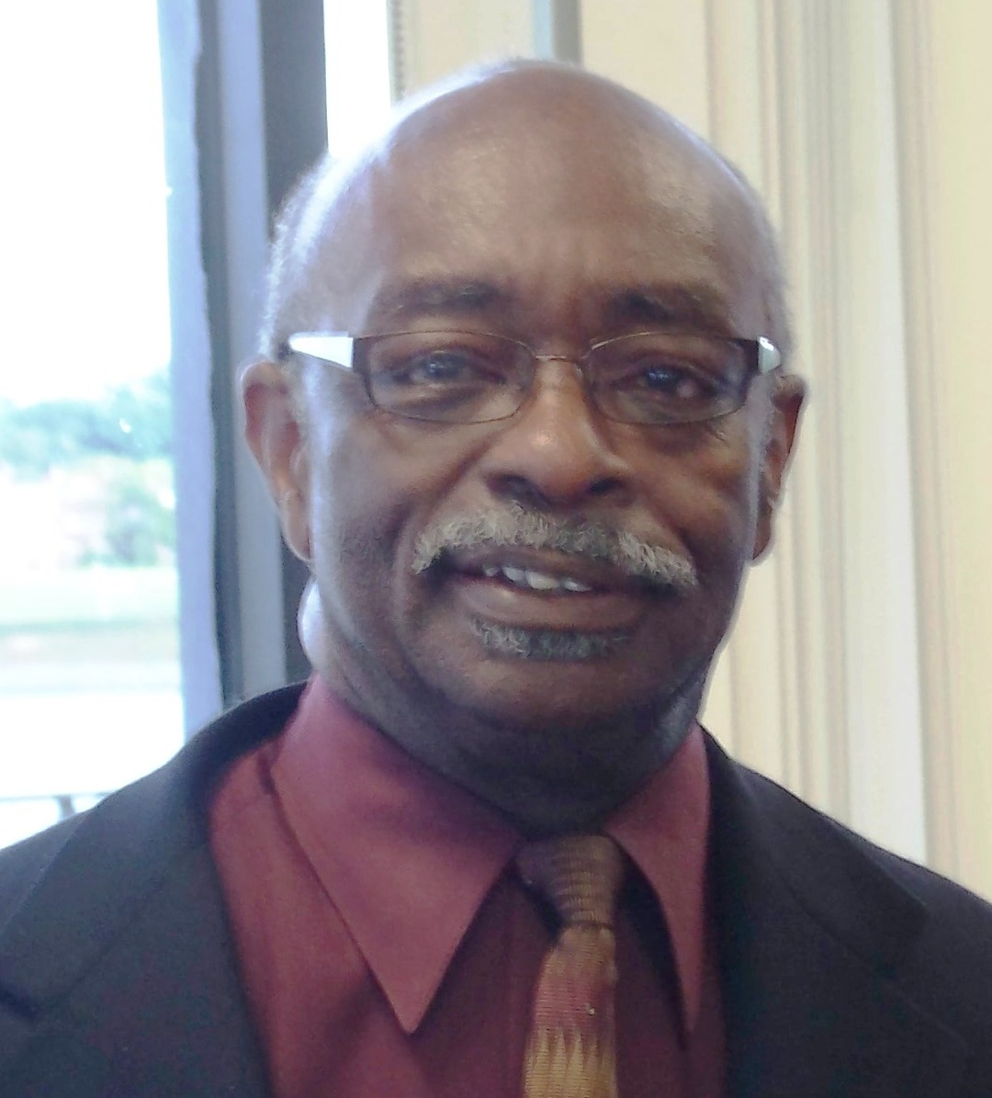
Dr. Horace R. Carney (ΟΔ), Interim Chair of Fine Arts Department, Alabama A&M University
Sinfonica Index
Volumes 1 – 3

Inaugural Issue, May 25, 2005
Antoine Thomkins, Editor
Phi Mu Alpha Zeta Rho Colony
The Mills Music Mission of the Zeta Rho Colony
The American Musicale at the Home of American Music

Volume 1, No. 1, October 6, 2005
Matthew Richardson, editor
Phi Mu Alpha Sinfonia: Money Power, Music Power, Man Power
Fisk Alumnus Featured Guest at University of Illinois Springfield
Tennessee Communications Association Donates $300
Celebrating Founders Day, October 6, 2005
Zeta Rho Advisors Honored by Tennessee Music Teachers Association

Volume 1, No. 2, January 25, 2006
Matthew Richardson, Editor
The Re-Activation of Zeta Rho
Man Power Music Power Money Power

Volume 1, No. 3, May 23, 2006
Matthew Richardson, Editor
Alpha and Beta Classes
Chapter Day
First President of Fisk Sinfonic Club Becomes Honorary Member
Man Power: Sinfonians Recognized at Spring Arts Festival Banquet
Music Power: Sinfonians Sing at Commencement
Man Power: Graduating Sinfonians (Darrel R. Jones, Antoine Thompkins)
Music Power: World Premiere Performance

Volume 2, No. 1, October 6, 2006
Matthew Richardson, Editor
Word from the President (Darius Gaines)
Harris Music Building Gets Refreshed
Chapter Day Celebration—A First for Most Participants
Man Power: UNCF/Melon Program
Music Power: Sinfonian Faculty Members Form Faculty Jazz Ensemble
Music Power: World Premiere Performance
Money Power

Volume 2, No. 2, January 25, 2007
Matthew Richardson, Editor
The New Gamma Class
Delta Class Alumnus Oral Moses ’74 Visits Campus
Zeta Rho Takes Coronation by Storm
Man Power: Zeta Rho Hosts Fall Workshop
Music Power: Province Mills Music Mission
Money Power

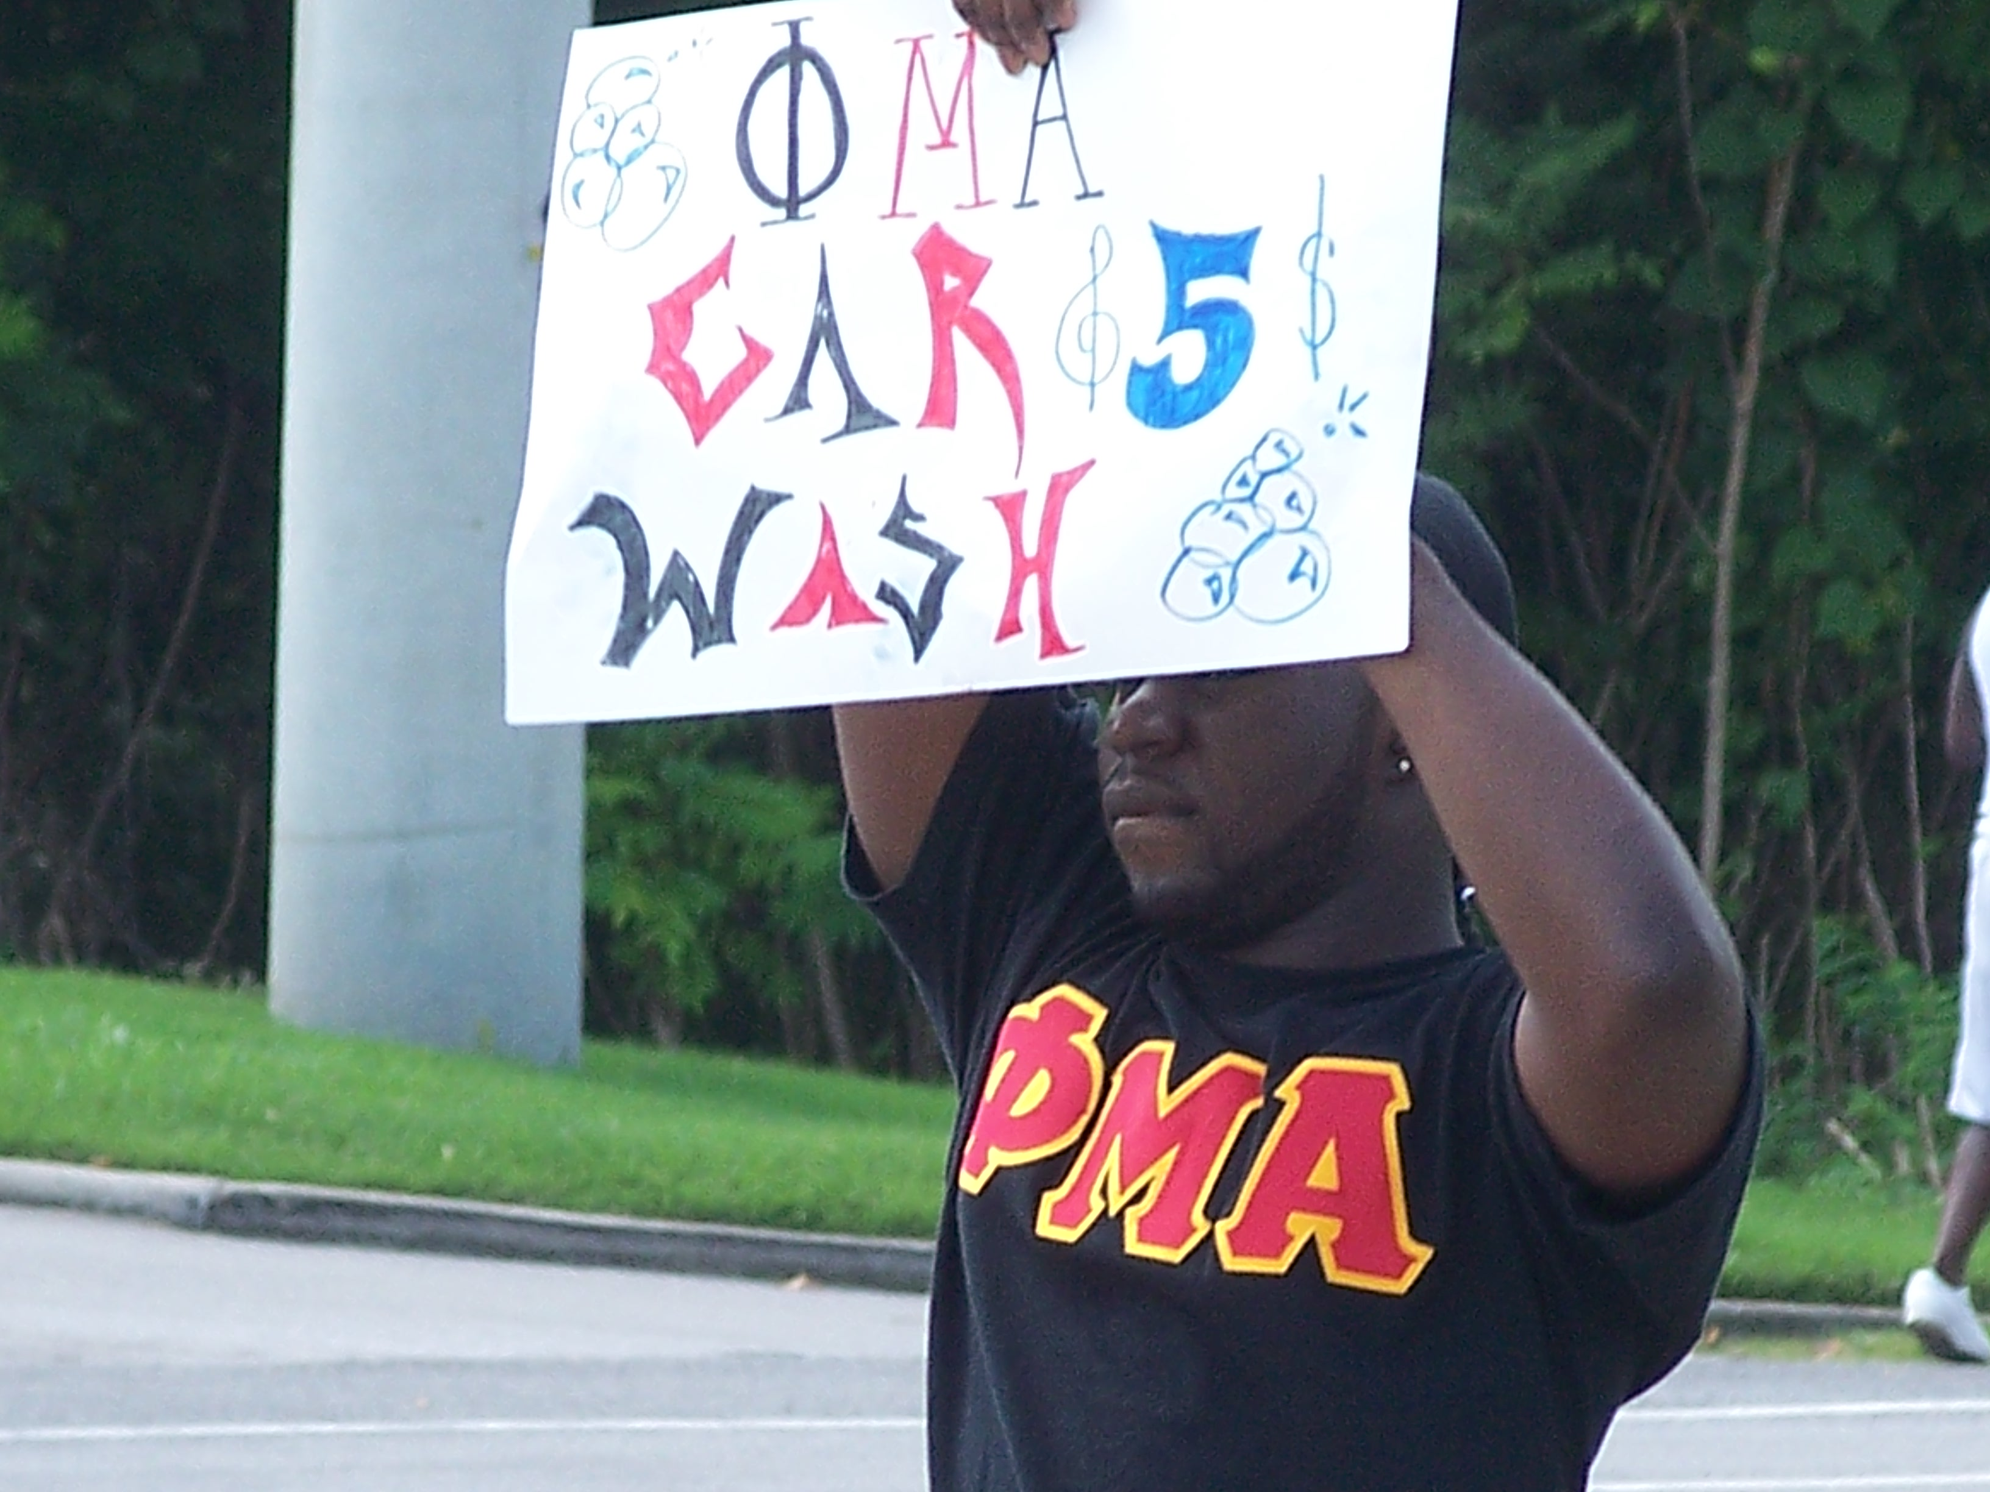
Volume 2, No. 3, May 23, 2007
Matthew Richardson, Editor
New Delta Class, April 26, 2007
Spring Fling 2007, University of Tennessee at Martin
Valentines Day Serenade Heats Up Cafeteria
Man Power: Supporting the Negro Spiritual Scholarship Foundation and a Gem
Money Power: Music for Mississippi
Music Power: Donna McElroy ’72 Serenaded after a Recital at Fisk

Volume 3, No. 1, October 6, 2007
Willis Ware, Editor
Freeze Pops Make Important Statement
Chapter Day 2007
National Hazing Prevention Week
Sinfonian Chosen for Fisk Music Business Program
Mills Music Mission
John W. Work III Memorial Foundation Keeps Sinfonian’s Memory Alive
Nashville Sinfonian Alumni Eat Together

Volume 3, No. 2, January 25, 2008
Willis Ware, Editor
New Epsilon Class, December 6, 2008
Phi Mu Alpha Ball
Dr. Richard M. Turner III Exemplifies the True Sinfonian
Vocal Technique and Fraternal Tradition
Open Mic Night
Homecoming 2007
New Life Loyal Sinfonian Program

Volume 3, No. 3, May 23, 2008
Word from the President (Willis Ware)
Sinfonians Complete Degree Requirements (Darius Gaines, Uwem Umontuen, Gregory Mason, Matthew Richardson)
Zeta Rho Alum Speaks at Baccalaureate Exercise
Collegiates Recognized by Fisk Music Faculty
Chapter Day
Morris Thomas Earns Ph.D.
Advisor Honored
Opera Workshop
International Music Business Series
Mellon Challenge

Backorder copies available at $2 each. Please send check or money order with your name/address to
Devin Mikell, Alumni Relations Officer
Zeta Rho Chapter of Phi Mu Alpha Sinfonia
Fisk University Music Department
1000 Seventeenth Avenue, North
Nashville TN 37208

Correction

The Publisher regrets the misspelling of the name of Fraternity Education Officer Rashaan Forbes in the May 23, 2008 issue of Sinfonica.

Officers 2008–2009
President Willis Ware
Vice President Rashaan Forbes
Secretary Troika Hanna
Treasurer Jermaine Johnson
Fraternity Education (FEO) Rashaan Forbes
Assistant FEO Jordan Holland
Historian P. J. Moton
Alumni Relations Devin Mikell
Warden Preston Wilson
Province Council Rep. Adrian Smith

