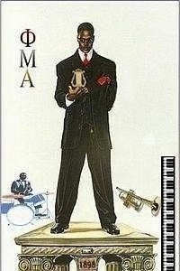 Sinfonica
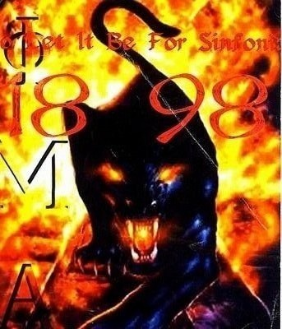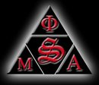
Volume 3, No. 2 January 25, 2008

The New Ε Class
December 6, 2007

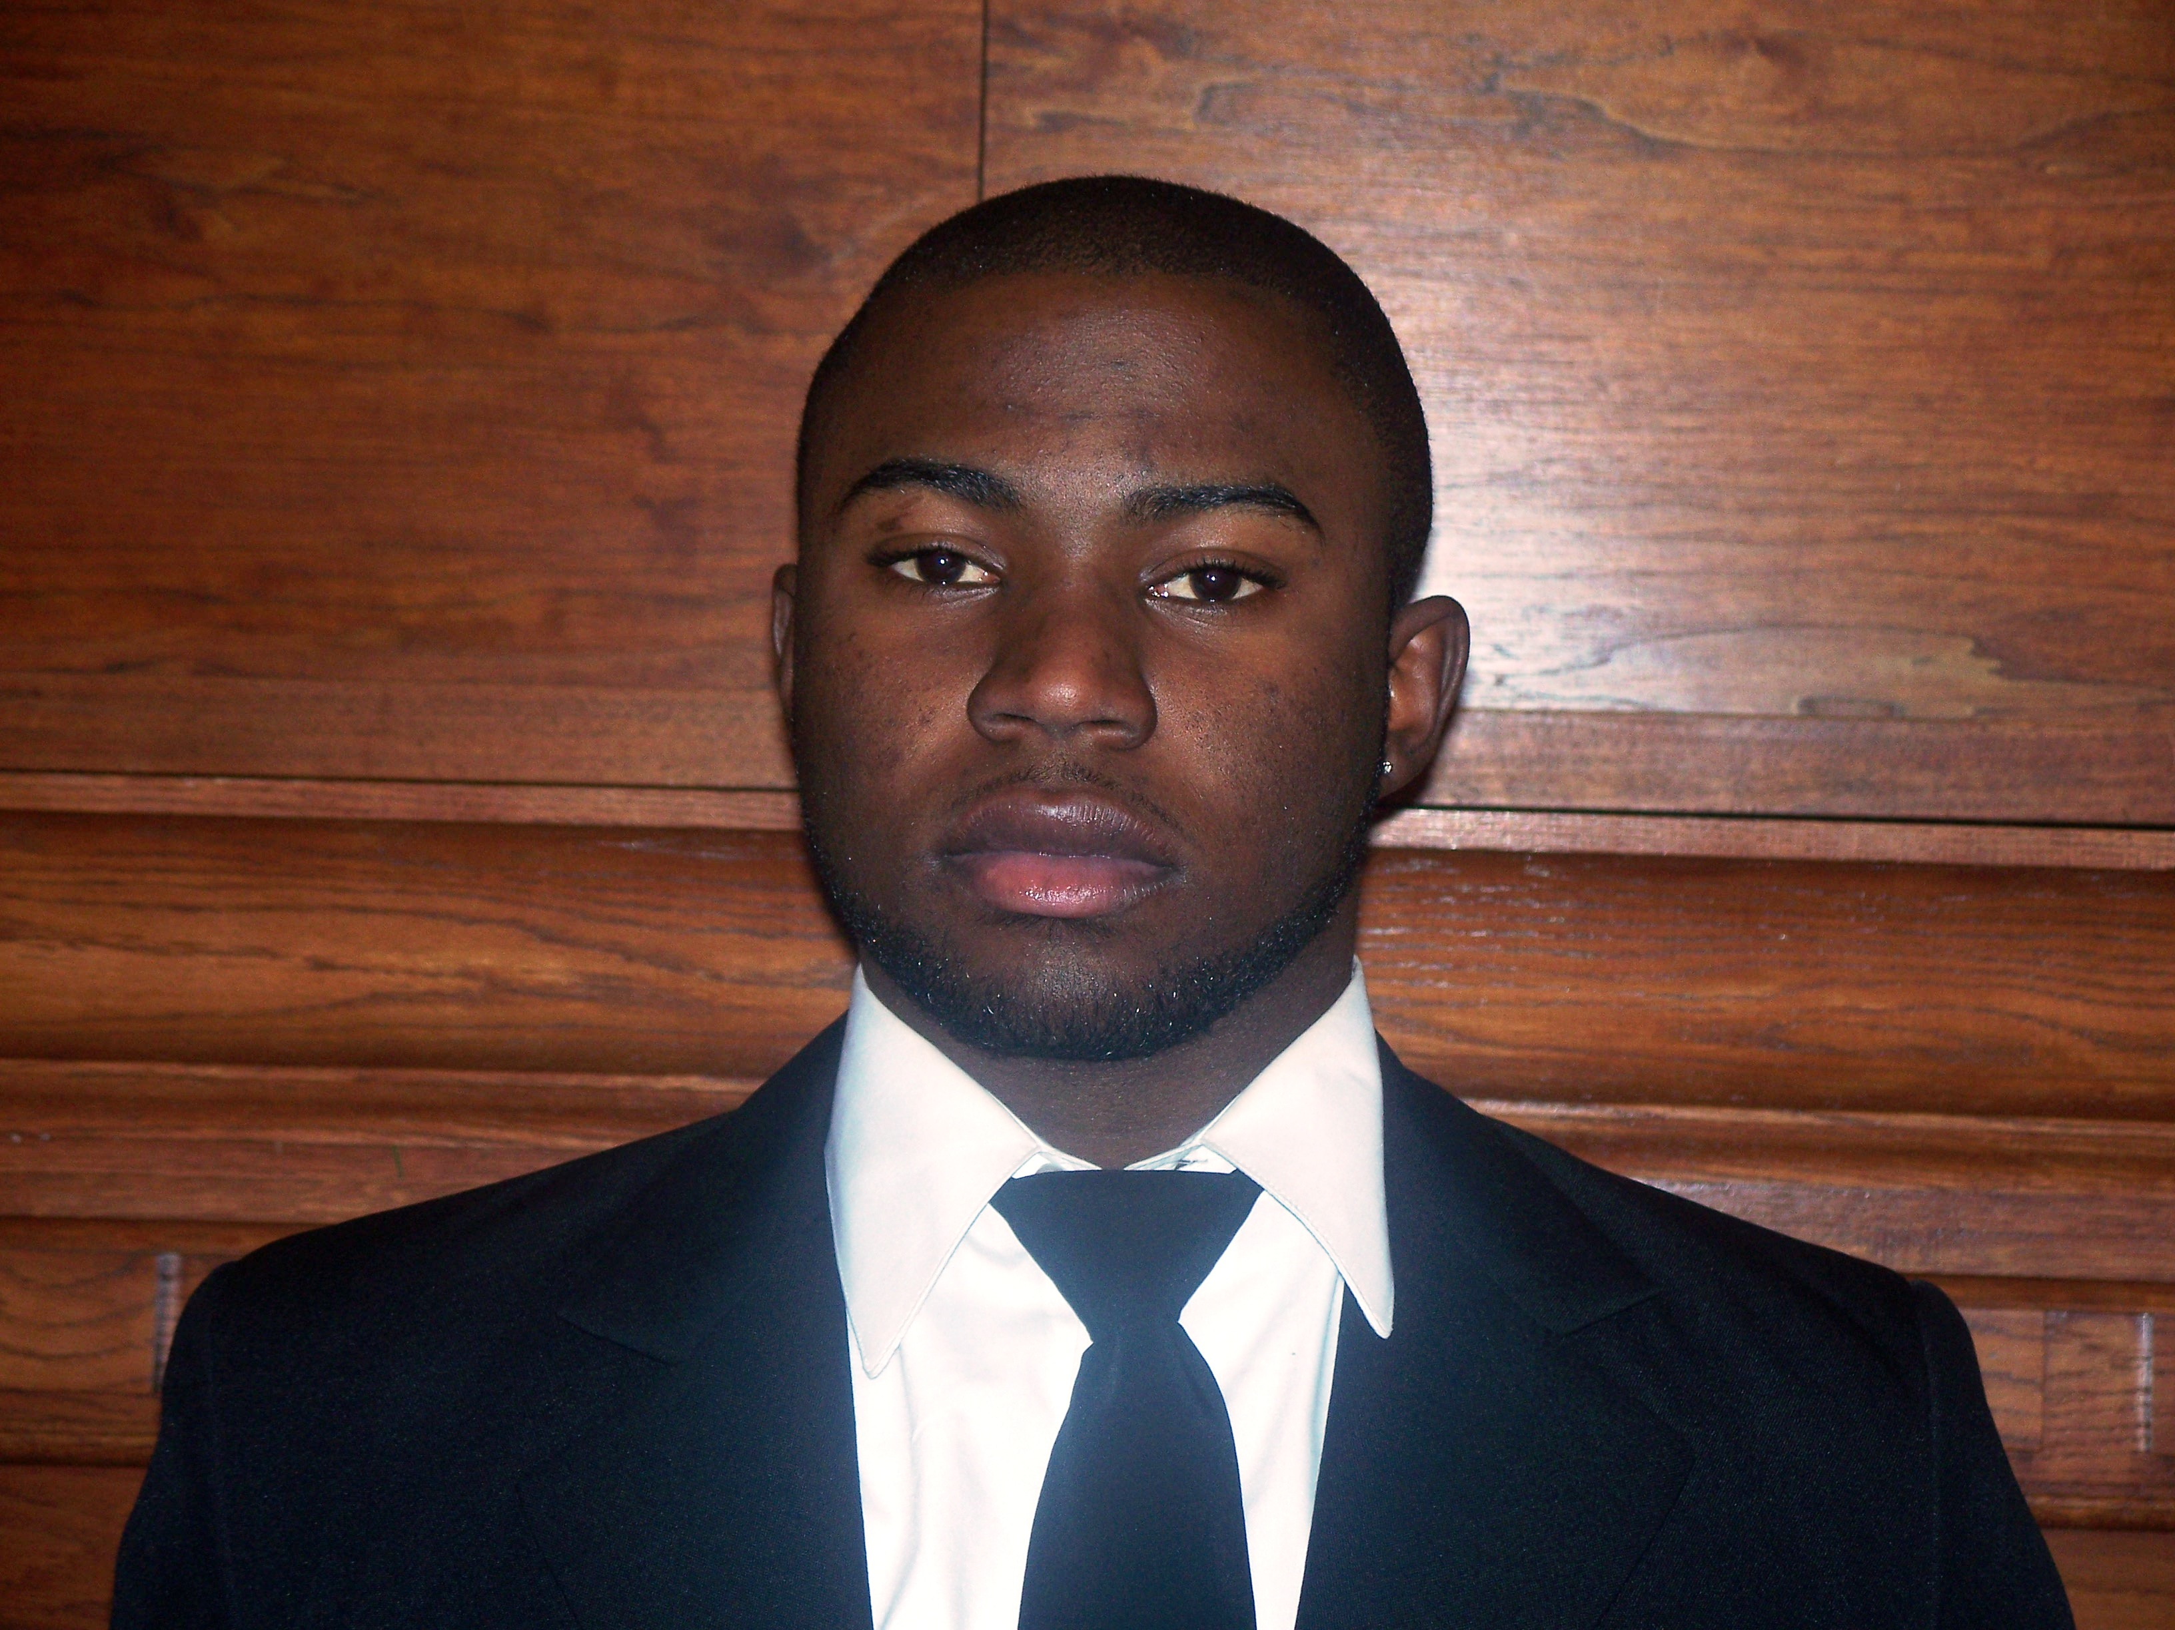
Adrian Antoine Smith, ‘11
Business Administration, Nassau, Bahamas

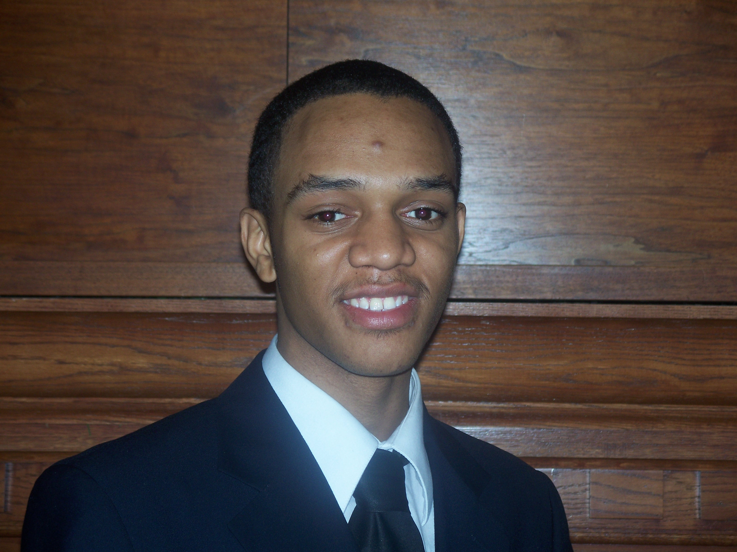
Jermaine Jamel Johnson. ’11, Business Administration, Brooklyn, New York

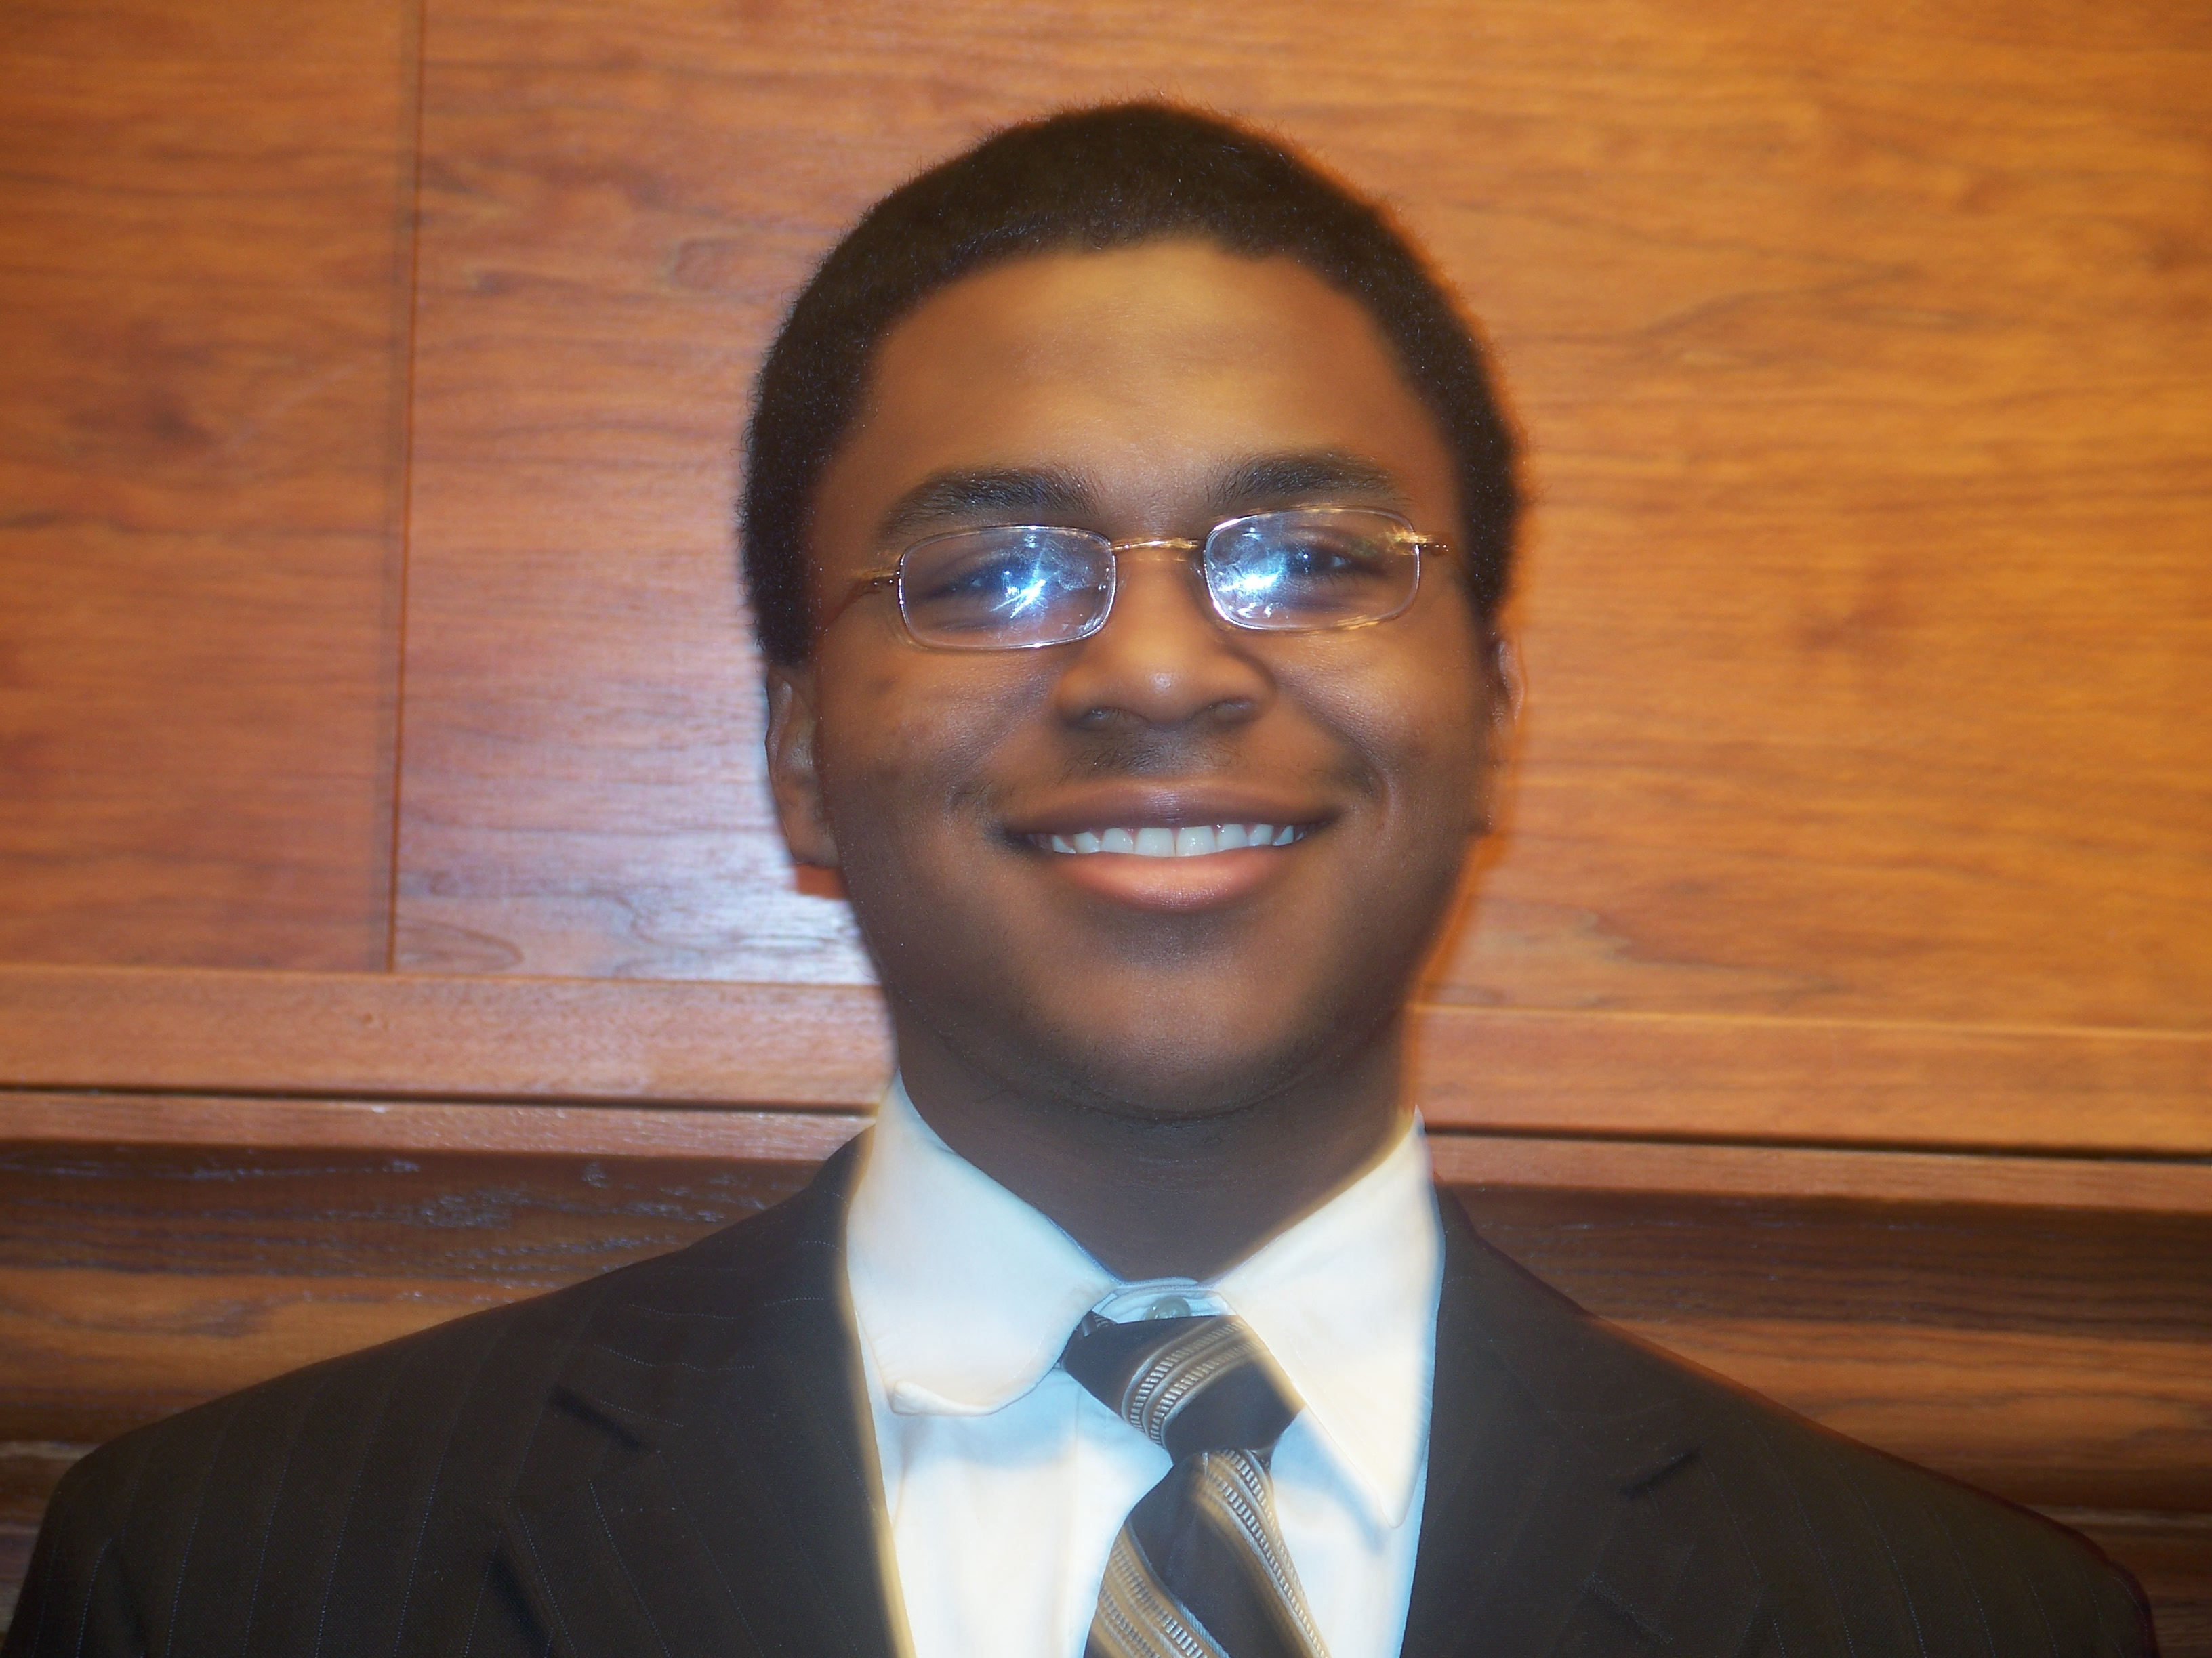

Keith Andre Anderson, Junior, ’11, Business Administration, Herculaneum, Missouri

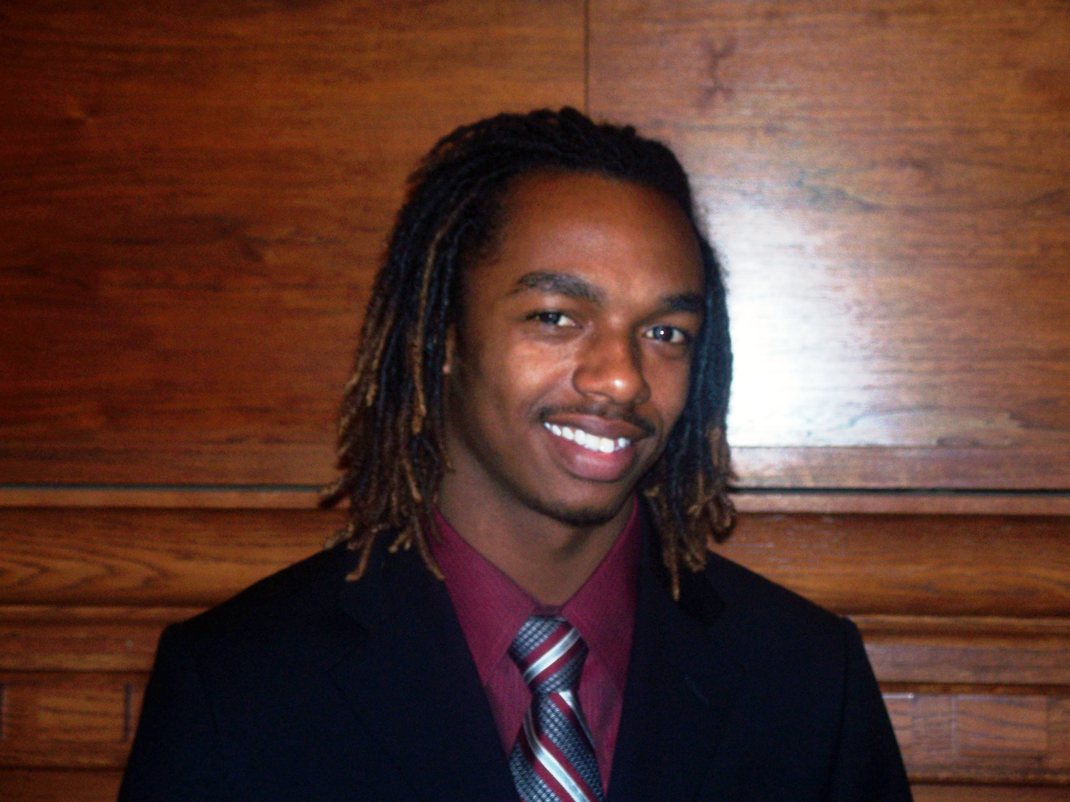
Pierre Jamar Moton, ’11,
Nursing, Birmingham, Alabama

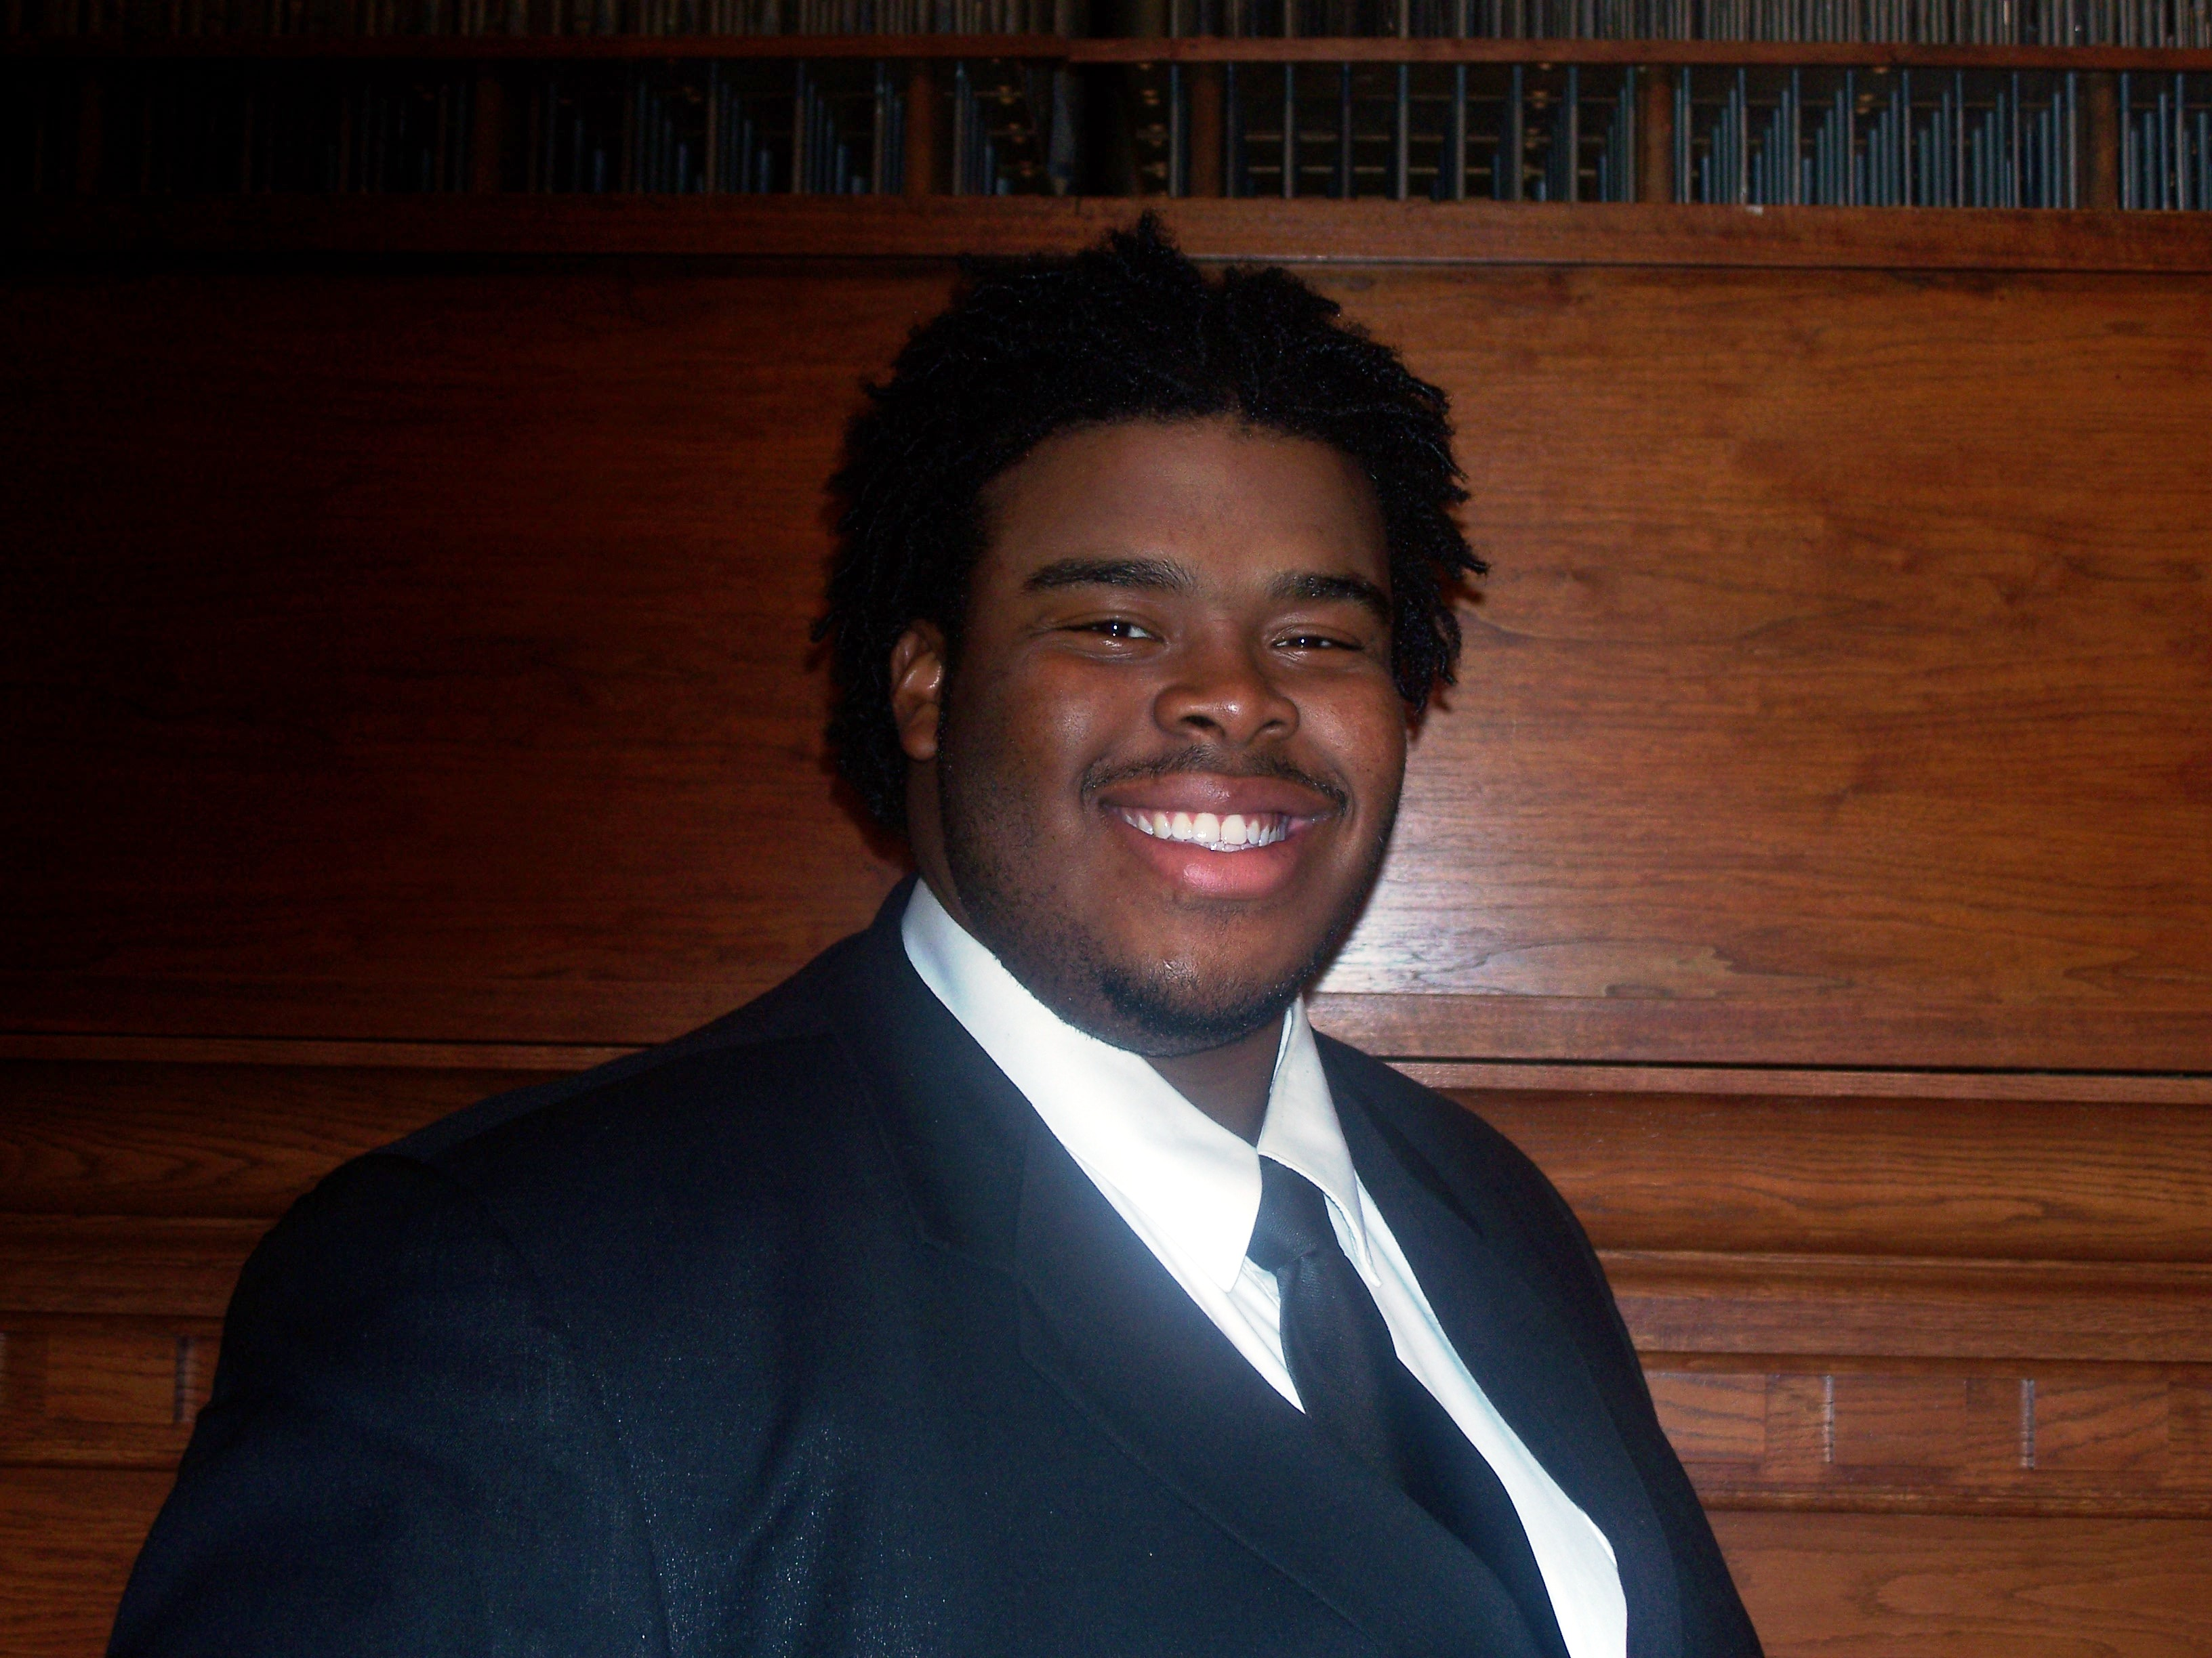
Jordan Alexander Holland, ’11, Music, Columbus, Ohio

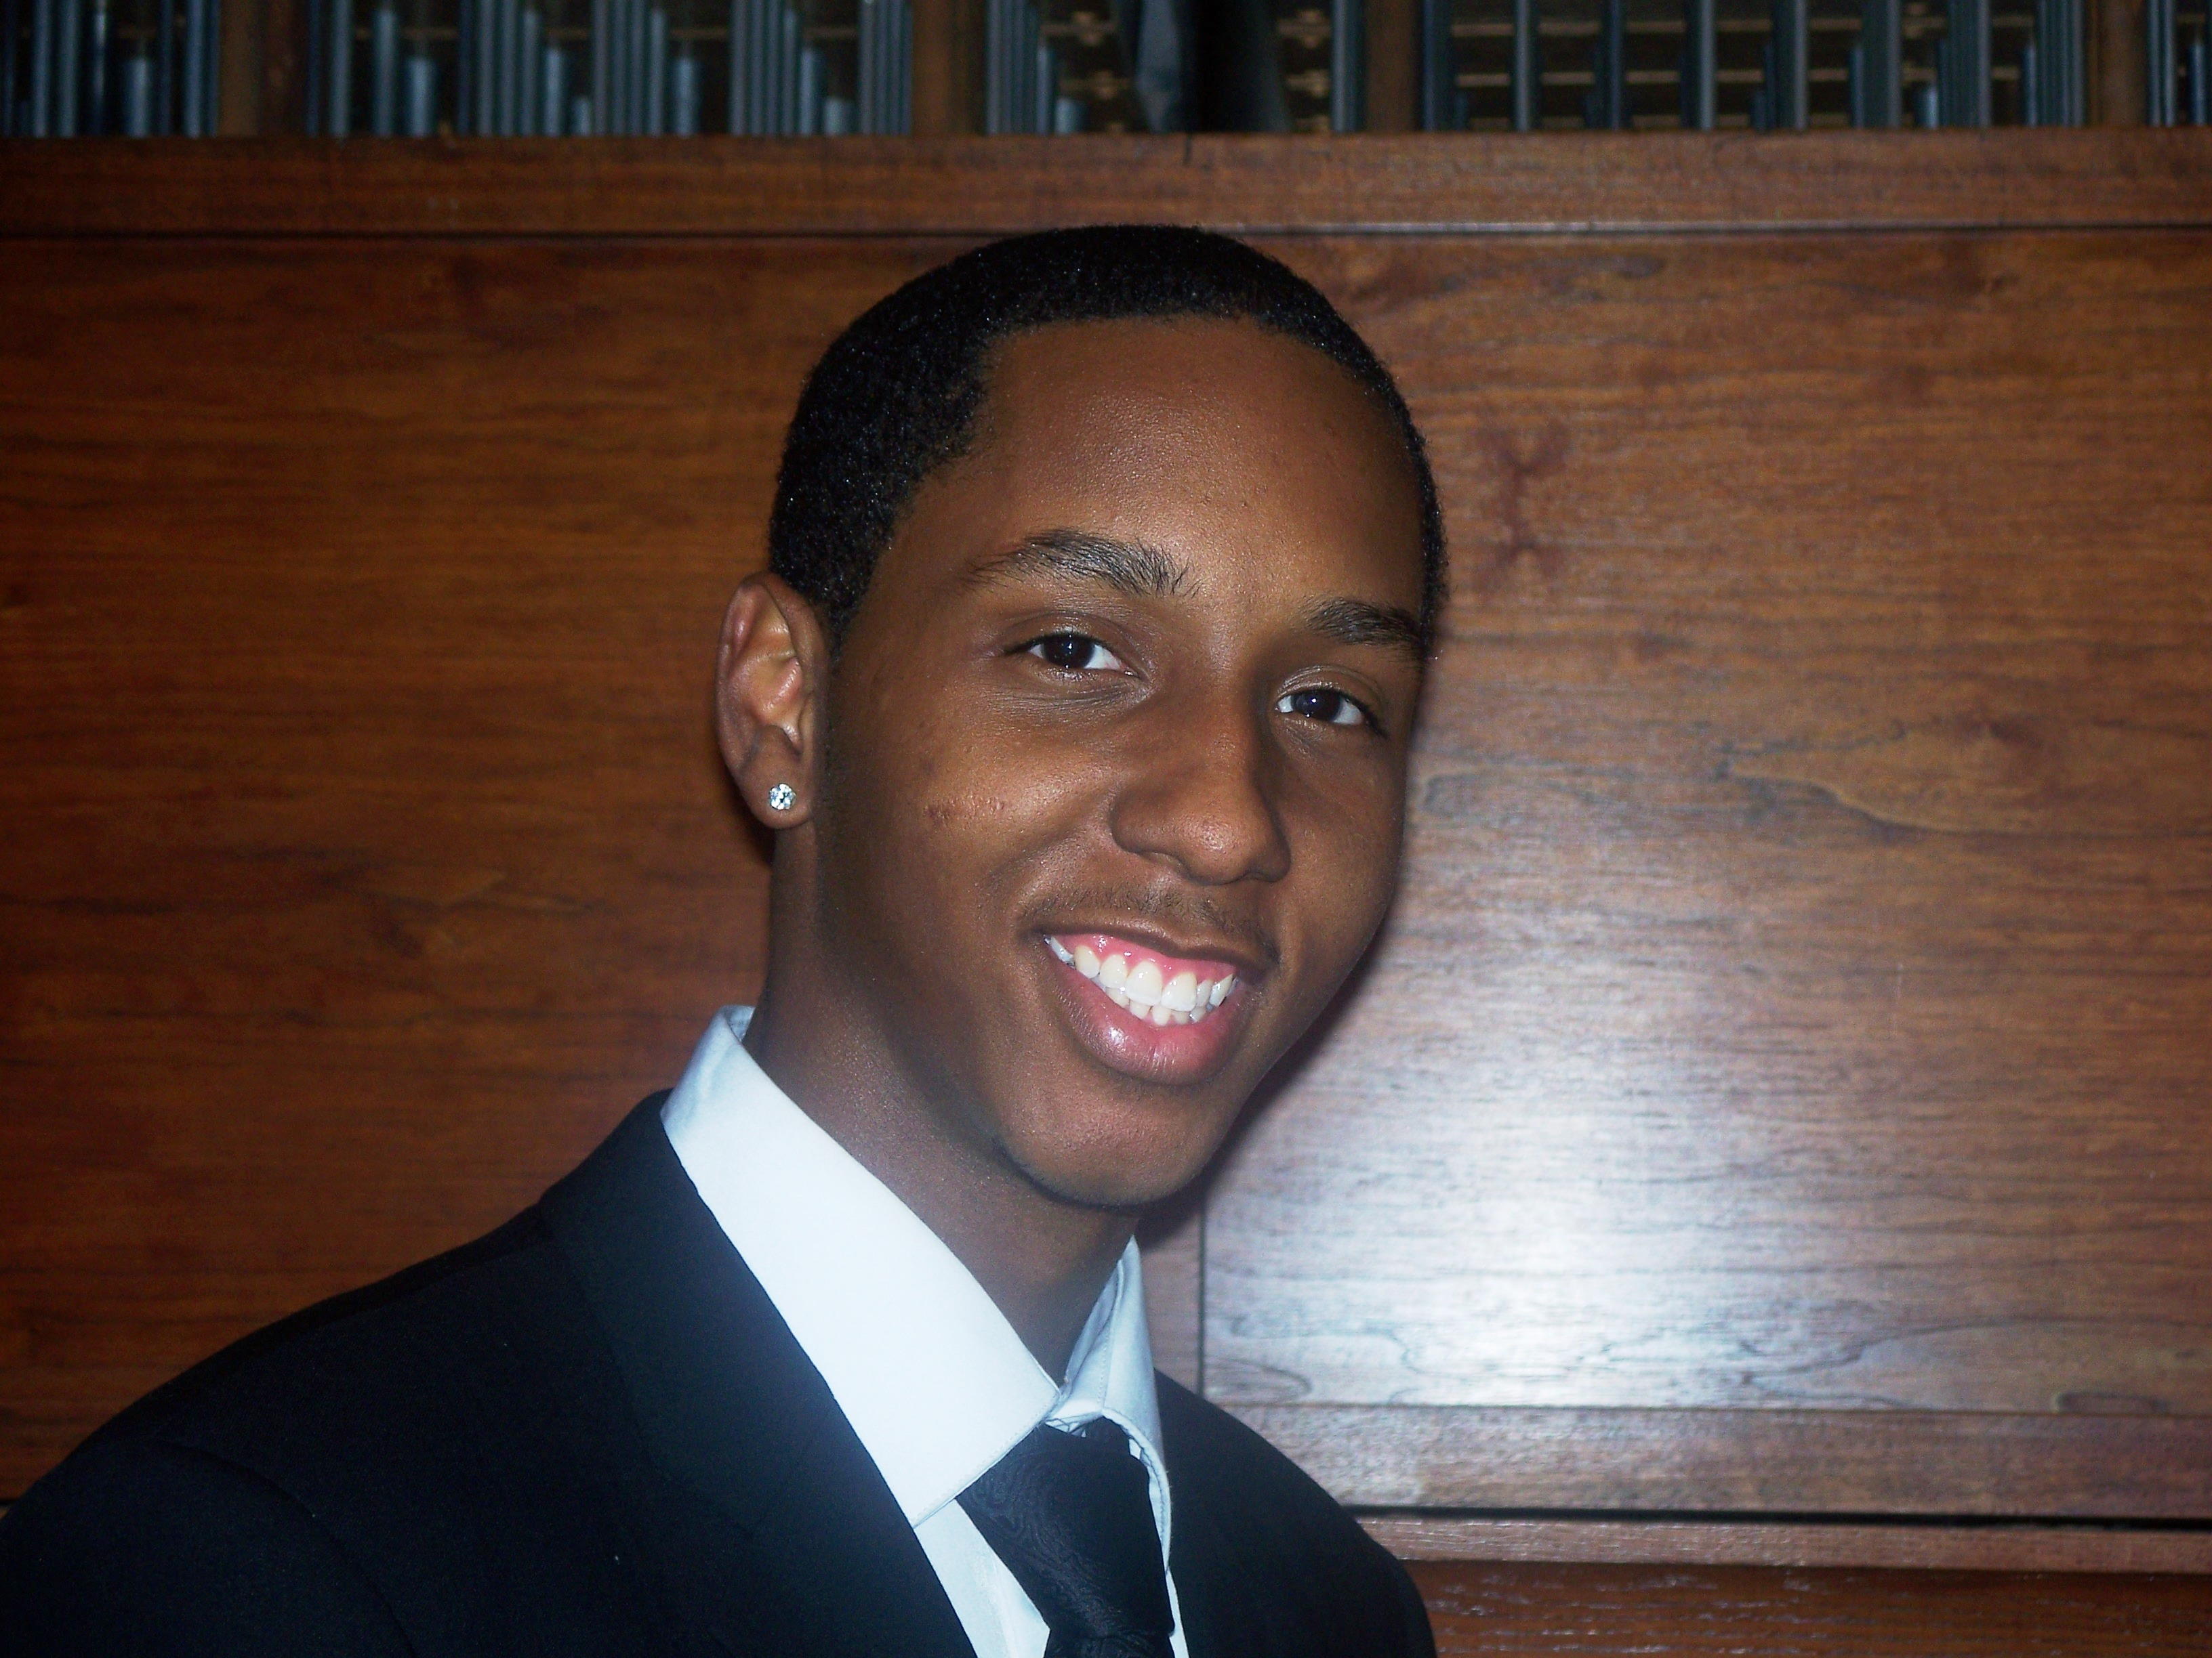
Marqo Dominique Patton, ’11, Business Administration (Music Business), Columbus, Ohio

* * * * * * * * * * * * * *
Willis Ware, Writer/Editor
zetarhochapter@hotmail.com
Zeta Rho Chapter
Phi Mu Alpha Sinfonia
Fisk University Music Department
1000 Seventeenth Avenue, North
Nashville, Tennessee 37208

Phi Mu Alpha Ball

Class, style and grace are just some of the many themes that surrounded the Evening of Red, Black and Gold. A large group of distinguished young men and women assembled themselves in the Appleton Room of Jubilee Hall to enjoy a night of elegance. Compliments to chefs Winterbourne Jones and Uwem Umontuen (New Δ), for providing a plethora of refreshments for guests.

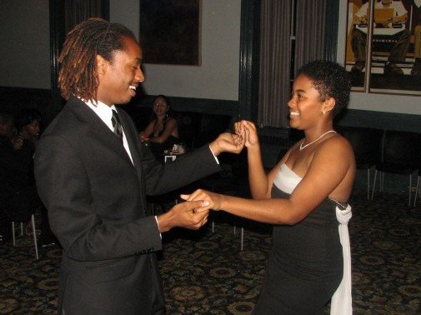

Candles illuminated the room and captured the eyes of every individual. Marqo Patton (PM) captured the ears of everyone with his rendition of You Loved Me (arr. Jill Scott). The night closed with the men of Phi Mu Alpha serenading all the women.

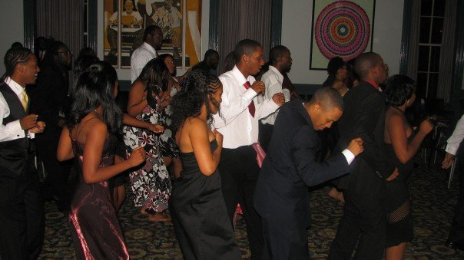

Photos courtesy of Uwem Umontuen (New Δ). Used by permission.
Dr. Richard M. Turner III (Α Class) Exemplifies the True Sinfonian
After ZP’s chartering on May 23, 1953, Richard M. Turner III served as its first secretary
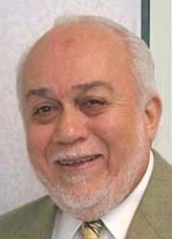
and second president, while attending Fisk as a pianist majoring in music. His passion for music began at the age of 5 as a young pianist striving to be the best. Turner attended Fisk on full scholarship and graduated with a B.A. in music in 1956. He went ahead to pursue not only his Masters at Indiana University but his Doctorate as well in music education.

Upon completion Turner returned to Fisk as chair of the Music Department and Director of the Jubilee Singers (1968–1971). Later, he headed Baltimore’s Community College to serve as Dean of Student Activities and in 1974 Dean of Faculty (Provost) for 8 years. From 1974 until 1979, Turner held the position as the minister of music for Union Baptist Church in Baltimore, MD. In 1980 Fisk awarded him the honorary Doctor of Humane Letters.

With remarkable leadership skills, Dr. Turner founded the Singing Presidents of the American Association of Community Colleges (AACC) which was a group of administrators who focused on barbershop style harmony! The American Association of Community Colleges Singers, was established shortly after whose repertoire consisted of a more wide span of music. Their astonishing debut performance was held at Caesar’s Palace in Las Vegas, NV for the annual AACC conference. The group toured successfully for 8 years.

Turner served as President for five different community colleges: Baltimore City Community College (President Emeritus), South Central Community College now known as Gateway Community College, Nashville Tech, Lane College, and Wayne County Community College District.

Turner is head of a consolidating business “Turner Executive Search Associates, LLC, are committed to excellence in advising and assisting colleges and universities, through the search process, to find outstanding candidates who are uniquely qualified for their key positions of educational leadership.”

Dr. Turner has exemplified through his character the true values and qualities that one should possess while embarking on the journey of life keeping the spirit of Orpheus alive.

I was priviledged to speak with Dr. Turner in a telephone interview on December 18, 2007. WW

Vocal Technique and Fraternal Tradition
Fraternity Education Officer Devin Mikel (New Α) led a workshop on vocal technique during the weekly rehearsal on Thursday, October 25. The workshop reminded Collegiate and Probationary Members of proper singing technique, listening and blending.
Open Mic Night

Roses are red, violets are blue, I like poetry how about you? Students gathered from all over campus to express their thoughts and ideas through spoken word, dance and song! Freshman Adrian Smith (PM) had the crowd going wild to the smooth sounds of his tenor sax!

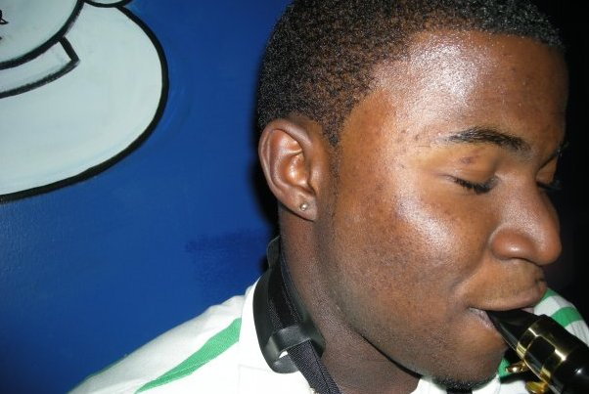
Photo courtesy of Darius Gaines. Used by permission.

Brothers from Belmont University (ΟΡ) and TSU (ΗΞ) attended. Sigma Alpha Iota member Camille Pritchett from TSU ended the poetry set by singing I Am Ready for Love (arr. India Arie).

Homecoming 2007


The 2007 Miss Phi Mu Alpha, Anycia Grady ’09 with her escort Uwem Umontuen (New Δ) at the Home-
coming Ball.

Photo courtesy of
Uwem Umontuen.

New Life Loyal Sinfonian Program

Visit www.Sinfonia.org/lifeloyal or call Daniel Krueger at 800.473.2649

Officers 2007–2008
President Darius Gaines
Vice President Devin Mikell
Secretary/Treasurer Gregory Mason
Fraternity Education (FEO) Devin Mikell
Historian Preston Wilson
Alumni Relations Willis Ware
Warden Uwem Umontuen

